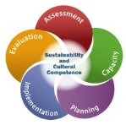

North Dakota

**Partnership for Success (PFS)**

Community Assessment

Community Grantee:

Contents

Introduction 3

Key Concepts of Assessment 3

Completing This Assessment 6

1. Self-Assessment 9

2. Involving Stakeholders in Assessment 10

3. Timeline for Completing Assessment 11

4. Community Demographic and Culture Assessment 12

5. Resources Assessment 15

5.1. Assessing ***Community*** Resources 15

5.2. Assessing ***Coalition*** Resources 16

6. Assessment of Readiness 18

6.1. Assessing ***Community*** Readiness 19

6.2. Assessing ***Coalition*** Readiness 22

7. Underage Drinking Consequences 24

8. Underage Drinking Consumption 26

9. Developing a Problem Statement 29

10. Why Underage Drinking in My Community: Intervening Variables 30

10.1. Retail Availability 31

10.2. Social Availability 34

10.3. Enforcement 38

10.4. Community Norms 40

11. Prioritizing Intervening Variables 44

12. Summary 47

13. Communication plan for sharing results of Assessment 49

14. Assessment Contributions 50

# Introduction

The Partnership for Success (PFS) grant (through the Substance Abuse and Mental Health Services Administration, [SAMHSA]) requires states to use the successful prevention systems and structures put in place through their completed Strategic Prevention Framework State Incentive Grant (SPF SIG).

SAMHSA’s PFS grant goals:

* Prevent the onset and reduce the progression of substance abuse
* Reduce substance abuse-related problems
* Strengthen prevention capacity/infrastructure at the state and community levels
* Leverage, redirect and align funding streams and resources for prevention

The North Dakota PFS plans to address the following substance abuse prevention priority: underage drinking among persons aged 12 to 20.

The North Dakota Department of Human Services’ Behavioral Health Division was awarded the PFS in 2015.

## Strategic Prevention Framework

SAMHSA’s [Strategic Prevention Framework (SPF)](http://www.samhsa.gov/capt/applying-strategic-prevention-framework) is a planning process for preventing substance use and misuse. The five steps and two guiding principles of the SPF offer prevention professionals a comprehensive process for addressing the substance misuse and related behavioral health problems facing their communities. The effectiveness of the SPF begins with a clear understanding of community needs and involves community members in all stages of the planning process.

Five Steps of the Strategic Prevention (SPF) Framework



Source: Center for Substance Abuse Prevention, 2005

The SPF planning process has four distinctive features. The SPF is:

* **Data driven:** Good decisions require data. The SPF is designed to help practitioners gather and use data to guide all prevention decisions—from identifying which substance misuse issues problems to address in their communities, to choosing the most appropriate ways to address those problems. Data also helps practitioners determine whether communities are making progress in meeting their prevention needs.
* **Dynamic:** Assessment is more than just a starting point. Practitioners will return to this step again and again: as the prevention needs of their communities change, and as community capacity to address these needs evolve. Communities may also engage in activities related to multiple steps simultaneously. For example, practitioners may need to find and mobilize additional capacity to support implementation once an intervention is underway. For these reasons, the SPF is a circular, rather than a linear, model.
* **Focused on population-level change:** Earlier prevention models often measured success by looking at individual program outcomes or changes among small groups. But effective prevention means implementing multiple strategies that address the constellation of risk and protective factors associated with substance misuse in a given community. In this way, we are more likely to create an environment that helps people support healthy decision-making.
* **Intended to guide prevention efforts for people of all ages:** Substance misuse prevention has traditionally focused on adolescent use. The SPF challenges prevention professionals to look at substance misuse among populations that are often overlooked but at significant risk, such as young adults ages 18 to 25 and adults age 65 and older.
* **Reliant on a team approach:** Each step of the SPF requires—and greatly benefits from—the participation of diverse community partners. The individuals and institutions you involve will change as your initiative evolves over time, but the need for prevention partners will remain constant.

## Key Concepts of Assessment

[Assessment](http://www.samhsa.gov/capt/applying-strategic-prevention-framework/step1-assess-needs) is the first step of the Strategic Prevention Framework. To change a problem, you must first understand it. The assessment step is sometimes referred to as “assessing needs” (or “needs assessment”) because the data collected during the assessment will reveal what a community, state, tribe, or jurisdiction needs in order to prevent substance abuse and promote wellness.

Undertaking a community assessment can provide many opportunities for the coalition and the community. A comprehensive assessment should:

* Create community consensus about the underage drinking problems in the community.
* Identify underlying factors that contribute to those problems.
* Identify and analyze environmental, social, and individual factors that contribute to the problems.
* Increase the likelihood that your coalition will select and implement policies and practices that actually will reduce underage drinking problems in the community.
* Establish baseline information to track the coalition’s progress.

**Assessment** involves gathering the following data:

* Nature and extent of substance use problems and related behaviors (this refers to substance use consequences and consumption, terms that may be more familiar)
* Risk and protective factors that influence substance use problems and related behaviors
* Available resources and readiness of the community to address these problems

Using data allows for a more objective decision-making process. The assessment should be able to answer the following questions about substance use:

* What problems and related behaviors are occurring?
* How often are the problems and related behaviors occurring?
* Where are these problems and related behaviors occurring?
* Which population groups experience more of these problems and related behaviors?

Some population groups are at greater risk than others, and thus experience disproportionate substance abuse problems. During the assessment process, you will need to collect data on these vulnerable populations, even if it is not readily available.

A health disparity is a difference in health that is “closely linked with social, economic, and/or environmental disadvantages.

Health disparities adversely affect groups of people who have systematically experienced greater obstacles to health based on their racial or ethnic group; religion; socioeconomic status; gender; age; mental health; cognitive, sensory, or physical disability; sexual orientation or gender identity; geographic location; or other characteristics historically linked to discrimination or exclusion.”

While substance abuse interventions usually don’t address these disadvantages directly, they often do address the factors that contribute to these disadvantages.

Since so many data are available, it is important to be strategic about the data you choose to collect.

* Purpose. What is your rationale about how the data you want to collect relate to the substance use problems and to the work of your coalition? What will this data tell you about community substance use problems in your community and especially where (the settings) the problems occur?
* Validity. Does the indicator measure what it says it does? For example, to what extent do the number of DUI arrests measure the prevalence of drinking while driving as opposed to the aggressive enforcement of local laws by police?
* Reliability. Is the indicator reported the same way each year or are there variances that could affect totals and make data comparison impossible?
* Availability. Are the data available year to year and at the needed geographic level (neighborhood, city, county)?
* Obtainability. Can the data be collected easily? Will the agency that tracks the data release them?
* Stability. How long has the agency been collecting the data? It is most useful to use indicators that have been collected for at least five years to identify trends.
* Cost. Can data be provided at no cost, or will the agency charge a fee? Is the fee reasonable and affordable?
* Relevance. Does the coalition think that the indicator accurately represents a major aspect of the community’s substance use problem(s)?

Two main types of data are collected in conducting a community assessment: primary data and secondary or archival data.

* Primary data include information that you collect and compile—such as counting the number of alcohol-related newspaper articles over a two-year period or the number of billboards in the community that advertise alcohol. It also may involve collecting data that are available but have not yet been compiled.
  + *For example, you might want to know how many children are removed from their homes when parental substance abuse is a factor. Or you might want to know how many and what percent of police calls for service involve alcohol or other drugs. You will need cooperation from the child welfare agency or police department allowing you to compile this information from their records.*
* Archival/secondary data are already being collected and compiled by someone else (generally a local or state agency) on a regular basis and can be requested if you know where to look and how to ask.
  + *For example:1) alcohol and other drugs-related arrests (from the local police department or state department of justice); 2) alcohol and other drug treatment data (from the county or state); 3) Licensed retail alcohol outlets and problem outlets (from the state or local agency that licenses alcohol outlets); 4) Alcohol-involved traffic fatalities and injuries (from the state highway patrol); and 5) Intravenous drug-related HIV/AIDS data (from the county or state health department).*

A **logic model** is a visual tool that shows the logic, or rationale, behind a program or process. Like a roadmap, it tells you where you are, where you are going, and how you will get there. In the prevention field, planners often use logic models to:

* Visualize how the pieces of a prevention plan fit together
* Provide explicit rationale for selecting prevention programs, policies, and practices to address substance use problems

When used as part of applying the Strategic Prevention Framework (SPF), logic models show the relationship between the following four elements:

* Problems and Related Behaviors
* Intervening Variables/Risk and Protective Factors (including local conditions)
* Prevention Strategies
* Expected Outcomes (short-term, intermediate and long-term)

**Assessment** is the first step in the strategic planning process.

**Epidemiology** is *how* we do the assessment.

**Logic model** is our “road map”—the first stop is assessing problems and related behaviors.

#### PFS Logic Model

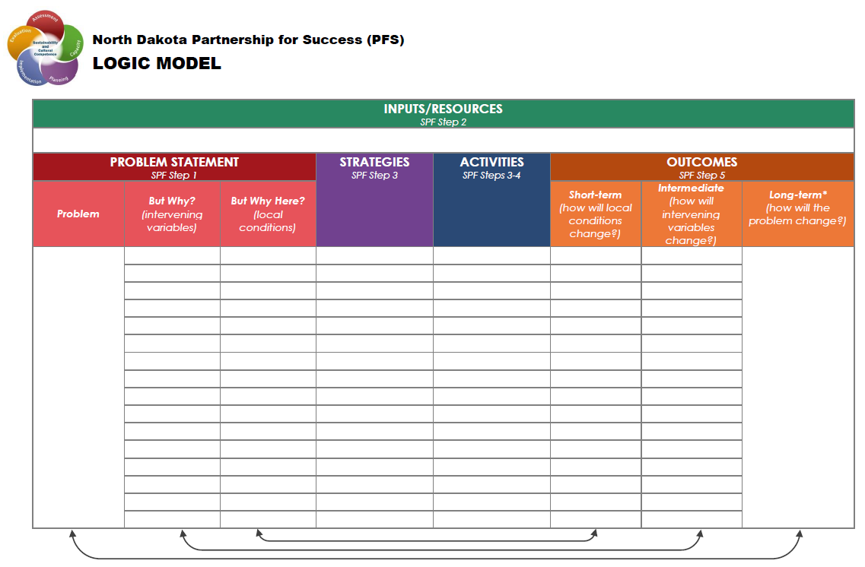

## Completing This Assessment

Each community has its own needs and assets, as well as its own culture and social structure -- a unique web of relationships, history, strengths, and conflicts that defines it. A community assessment helps to uncover not only needs and resources, but the underlying culture and social structure that will help you understand how to address the community's needs and utilize its resources.

This Community Assessment is broken up into the following four sections:

1. **Preparing for the Community Assessment**
2. **Assess Community Capacity**
3. **Assess the Problem**
4. **Summarize Findings and Communicate**

The flowchart on the next page walks through the steps you and your community will be taking in these four sections.

**A final copy of the Community Assessment Workbook should be submitted electronically no later than February 15, 2017 to** [**lauranderson@nd.gov**](mailto:lauranderson@nd.gov)**.**



Preparing to Complete the Assessment

# Self-Assessment

In order to begin completing this workbook, it is important to have a thorough understanding and knowledge of the SPF process, coalition building, and more. The self-assessment will assist in determining areas where you could increase your own capacity. Please reach out to the Training and Technical Assistance staff to connect you with resources and tools. Also, resources are available at [www.prevention.nd.gov](http://www.prevention.nd.gov).

* 1. **In the table below, please rate the level of your knowledge (that of the primary PFS coordinator) in each of the areas listed. Please place an “X” in the boxes to indicate your responses.** This tool will help you identify your level of capacity and readiness, and identify where your capacity needs to be increased.

|  |  |  |  |
| --- | --- | --- | --- |
| ***1 = Not very knowledgeable*** | ***2 = A little knowledgeable*** | ***3 = Somewhat knowledgeable*** | ***4 = Very knowledgeable*** |

|  |  |  |  |  |
| --- | --- | --- | --- | --- |
|  | **1** | **2** | **3** | **4** |
| **The Strategic Prevention Framework** |  |  |  |  |
| **Substance abuse prevention** |  |  |  |  |
| **Ensuring cultural competence in implementation** |  |  |  |  |
| **Evidence-based prevention strategies** |  |  |  |  |
| **Adaptation of strategies** |  |  |  |  |
| **Action planning for implementation** |  |  |  |  |
| **Ensuring sustainability in implementation** |  |  |  |  |
| **Logic models** |  |  |  |  |
| **Identification of indicators for evaluation** |  |  |  |  |
| **Identification of data sources for evaluation** |  |  |  |  |
| **Data collection for evaluation** |  |  |  |  |
| **Data analysis** |  |  |  |  |
| **Reporting evaluation data** |  |  |  |  |

* 1. **In a paragraph or more, summarize the areas indicated above where you excel and areas you need to build your knowledge. Identify the steps you will take to enhance your knowledge in these areas.**

|  |
| --- |
|  |

#### SPF SIG Review

Following the spirit of the Strategic Prevention Framework, it is important to evaluate past efforts and utilize that information in planning future efforts. Answer the questions below to the best of your knowledge. If possible, meet with individuals who played a large role in the implementation of SPF SIG in your community. Also, review your community’s *SPF SIG Final Evaluation Report*, which was provided by the Wyoming Survey and Analysis Center (WYSAC) in October 2016.

* 1. **What parts of your community’s implementation of the SPF SIG project worked well and why?**

|  |
| --- |
|  |

* 1. **In the implementation of the SPF SIG, were there challenges that were not adequately addressed? What parts of implementing the SPF SIG did not work well and why?**

|  |
| --- |
|  |

* 1. **Please describe any lessons learned through the SPF SIG and how you plan to apply these to the PFS.**

|  |
| --- |
|  |

# 

# Involving Stakeholders in Assessment

Involving members of your coalition as well as the various community groups in the community assessment process increases the likelihood of overall success. This encourages both trust in the process and community buy-in and support, not only of the assessment, but of whatever actions are taken as a result of it. Full community participation in planning and carrying out an assessment also promotes leadership from within the community and gives voice to those who may feel they have none.

In considering the partners you want to have assist in this assessment process, it will be important that membership is diverse, and that the individuals involved are knowledgeable about and have access to their organization’s data. Encouraging participation of diverse populations, cultures, ethnicities, gender, sexual orientation, disability and age groups to support the development and implementation of our assessment is vital to ensure cultural relevance. Also, it is important to consider who might have a stake in this effort.

Please reach out to the Training and Technical Assistance staff to connect you with resources and tools if you would like assistance in connecting with stakeholders ([www.prevention.nd.gov/pfs](http://www.prevention.nd.gov/pfs)).

* 1. **Complete the table below, identifying individuals/groups to involve in the community assessment process.**

|  |  |  |
| --- | --- | --- |
| **Community Group/Individual** | **Involve in Assessment?** *(Yes or No)* | **If yes, provide contact information** |
| **Law Enforcement Community** |  |  |
| **Judicial Community (judges, probation, attorneys, etc.)** |  |  |
| **Government (mayor, elected officials)** |  |  |
| **Alcohol industry** |  |  |
| **Local businesses** |  |  |
| **Civic organizations** |  |  |
| **Media (newspaper, radio stations, etc.)** |  |  |
| **Faith organizations** |  |  |
| **Education (principal, superintendent, teacher, counselor, coach, etc.)** |  |  |
| **Healthcare (physician, nurse, etc.)** |  |  |
| **Behavioral Health treatment (counselors, social workers, Licensed addiction counselors)** |  |  |
| **Youth and Youth Organizations (SADD, Boys and Girls Club, 4-H, etc.)** |  |  |
| **Other:** |  |  |

* 1. **In a paragraph or more, summarize your findings from the table above. What partners have you identified as being important to assist in the assessment process? Summarize your plans for reaching out and recruiting these partners to be a part of the assessment process.**

|  |
| --- |
|  |

# Timeline for Completing Assessment

Once you have identified and brought together stakeholders to assist in the assessment process, one of your first agenda items should be to determine a timeline for completing this Community Assessment. You will need to establish roles and articulate who will be responsible for making sure each portion of the assessment workbook gets completed.

Reference the flowchart on page 8 when completing the “Assessment Section” column. Identify the specific action steps required to complete for each assessment section. The more specific your action steps are, the more successful you will be. There should be multiple action steps for each section of the assessment. Try to divide the action steps up as equally as possible among the identified stakeholders, considering the experience, and “stake” of each stakeholder.

Keep in mind the final copy of the Community Assessment Workbook should be submitted electronically no later than February 15, 2017 to [lauranderson@nd.gov](mailto:lauranderson@nd.gov).

* 1. **Complete the table below with the Assessment Stakeholders identified in Table 2.2.**

|  |  |  |  |  |  |
| --- | --- | --- | --- | --- | --- |
| Assessment Section | Action Step | Responsible Person | Deadline | Resources Needed | Date Completed |
|  |  |  |  |  |  |
|  |  |  |  |  |  |
|  |  |  |  |  |  |
|  |  |  |  |  |  |
|  |  |  |  |  |  |
|  |  |  |  |  |  |
|  |  |  |  |  |  |
|  |  |  |  |  |  |
|  |  |  |  |  |  |
|  |  |  |  |  |  |
|  |  |  |  |  |  |
|  |  |  |  |  |  |
|  |  |  |  |  |  |
|  |  |  |  |  |  |
|  |  |  |  |  |  |

# Community Demographic and Culture Assessment

The purpose of this section is to:

* Define the community area you will be providing services through the PFS. If your service area includes multiple counties, this section needs to consider all of these counties.
* Provide context for reviewing the other data in this workbook.
* Provide information on community culture, which must be considered when selecting and implementing evidence-based strategies.

Review the data available through Census Bureau’s Quick Facts tool [<https://www.census.gov/quickfacts/table/PST045215/00>] or the American Communities Survey five-year estimates through the Census [<https://www.census.gov/programs-surveys/acs/>] to complete this section. Other resources could include the North Dakota Compass website (<http://www.ndcompass.org/>), your local chamber of commerce/tribal government, or recent previous community assessments.

##### Data Review

* 1. **Define your service area. Include a list of the county(s)/segments and towns within each county/segment. Utilize the table template below as a guide.**

|  |
| --- |
|  |

|  |  |
| --- | --- |
| COUNTY 1 | **COUNTY 2** |
| TOWN 1 | TOWN 1 |
| TOWN 2 | TOWN 2 |
|  | TOWN 3 |

* 1. **Identify the** [*Human Service Center Region*](http://www.nd.gov/dhs/locations/regionalhsc/) **that encompasses your service area.**

|  |
| --- |
|  |

* 1. **Identify the** [*Regional Education Association(s)*](http://www.ndrea.org/index.php?id=3) **that encompass your service area.**

|  |
| --- |
|  |

* 1. **Describe the population of your service area (include total population, gender, and age groups). Include a description of population differences between towns and/or county(s)/segments within your service area.**

|  |
| --- |
|  |

* 1. **Describe the various cultural backgrounds present in your service area (include race, ethnicity, any languages other than English spoken in your community, etc.). Include a description of cultural differences between towns and/or county(s)/segments within your service area.**

|  |
| --- |
|  |

* 1. **Describe the average educational level and most common fields of employment in your service area. Include a description of education/employment differences between towns and/or county(s)/segments within your service area.**

|  |
| --- |
|  |

* 1. **Describe the average household size, income, and poverty data in your service area. Include a description of household size and income differences between towns and/or county(s)/segments within your service area.**

|  |
| --- |
|  |

* 1. **Describe the community history within your service area (every community has a history of the events and forces that have affected and helped to shape it, it is not uncommon for people in diverse ethnic or cultural groups to interpret the same event differently). Include a description of community history differences between towns and/or county(s)/segments within your service area.**

|  |
| --- |
|  |

##### Summary

* 1. **Review all the information you gathered above and summarize the key characteristics of your service area’s demographics and culture. Include a description of differences between towns and/or county(s)/segments within your service area.**

|  |
| --- |
|  |

Assess Community Capacity

# Resources Assessment

Resources include anything a community can use to help address prevention needs, such as:

* People (for example, staff and volunteers)
* Specialized knowledge and skills (for example, research expertise)
* Community connections (for example, access to population groups)
* Concrete supplies (for example, money, and equipment)

A resource assessment describes current resources and resources that could be directed toward addressing the community’s substance use problems. A resource assessment is important because it

* Provides a way for the community to use its existing capacity.
* Accounts for community assets and resources.
* Describes the community by focusing on positive rather than negative aspects.
* Identifies ways that build member capacity.
* Expands the identification of assets and resources to include more than just programs and agencies.
* Identifies community groups or individuals (stakeholders) who might be willing to participate in the coalition or support the coalition’s efforts.

A well-planned and focused assessment will produce far more valuable information than one that casts a wide net. To that end, it’s helpful to focus assessments on relevant resources that are related to your priority problem of underage drinking. At the same time, keep in mind that useful and accessible resources may also exist outside of the substance use prevention system.

**Community Sectors** *(\**[*Drug Free Community Grant*](http://www.samhsa.gov/grants/grant-announcements/sp-14-002) *[a community grant opportunity offered through SAMHSA] required sectors)*

* Businesses*
* Child Care Providers
* Civic/Volunteer Groups*
* Courts & Probation
* Cultural Groups and Organizations
* Elementary/Secondary Education*
* Government*
* Healthcare Professionals*
* Higher Education
* Human and Social Service Providers
* Law Enforcement*
* Media*
* Parents*
* Religious/Fraternal Organizations*
* Senior Citizens
* Youth*
* Youth Serving Organizations*
* Others*



### Assessing ***Community*** Resources

### List existing community stakeholder groups in your service area (include youth-serving organizations, religious or fraternal organizations, civic and volunteer groups).

|  |  |  |  |
| --- | --- | --- | --- |
| **Name of Group** | **Contact Person** | **Mission/Goals of Group** | **Community Sector Represented** *(identify from list above)* |
|  |  |  |  |
|  |  |  |  |
|  |  |  |  |
|  |  |  |  |
|  |  |  |  |
|  |  |  |  |

### List any individual stakeholders in your service area, not already represented above.

|  |  |  |
| --- | --- | --- |
| **Stakeholder Name** | **Contact Information** | **Community Sector Represented** *(identify from list above)* |
|  |  |  |
|  |  |  |
|  |  |  |
|  |  |  |
|  |  |  |
|  |  |  |

### Summarize any other unique community resources (supplies, building space, funding, etc.)

|  |
| --- |
|  |

### Assessing ***Coalition*** Resources

As part of the PFS project deliverables, you are required to identify or establish a coalition to serve as the local advisory/work group to the community’s efforts.

### For each community sector listed below:

### a) Identify organizations or individuals who are currently ACTIVE members of your coalition, and

### b) Where there is no active membership, identify potential organizations or individuals that could represent the sector.

### An individual/organization should only be listed one time.

|  |  |  |
| --- | --- | --- |
|  | **Active Member (list individual/organization)** | **Potential Member (list individual/organization)** |
| **Businesses\*** |  |  |
| **Child Care Providers** |  |  |
| **Civic/Volunteer Groups\*** |  |  |
| **Courts & Probation** |  |  |
| **Cultural Groups and Organizations** |  |  |
| **Elementary/Secondary Education\*** |  |  |
| **Government\*** |  |  |
| **Healthcare Professionals\*** |  |  |
| **Higher Education** |  |  |
| **Human and Social Service Providers** |  |  |
| **Law Enforcement\*** |  |  |
| **Media\*** |  |  |
| **Parents\*** |  |  |
| **Religious/Fraternal Organizations\*** |  |  |
| **Senior Citizens** |  |  |
| **Youth\*** |  |  |
| **Youth Serving Organizations\*** |  |  |
| **Others\*** |  |  |

*\*Drug Free Community Grant required sectors*

### Complete the checklist below by placing an “X” in the box that most appropriately indicates the presence or absence of the characteristic in your community coalition.

|  |  |  |  |  |  |
| --- | --- | --- | --- | --- | --- |
| **Coalition Structure** | | | | | |
|  | **Absent** | **Present but Limited** | **Present** | **NA** | **Don’t Know** |
| **Has written job descriptions** |  |  |  |  |  |
| **Has a core planning group** |  |  |  |  |  |
| **Has committees** |  |  |  |  |  |
| **Has by-laws/rule of operation** |  |  |  |  |  |
| **Has Mission statement in writing** |  |  |  |  |  |
| **Has goals and objectives in writing** |  |  |  |  |  |
| **Provides for regular, structured meetings** |  |  |  |  |  |
| **Establishes effective communication mechanisms** |  |  |  |  |  |
| **Has clear roles and responsibilities for members in written form** |  |  |  |  |  |
| **Has organization chart** |  |  |  |  |  |

|  |  |  |  |  |  |
| --- | --- | --- | --- | --- | --- |
| **Coalition Process** | | | | | |
|  | **Absent** | **Present but Limited** | **Present** | **NA** | **Don’t Know** |
| **Has processes for decision making** |  |  |  |  |  |
| **Has processes for problem-solving and conflict resolution** |  |  |  |  |  |
| **Has process for resource allocation** |  |  |  |  |  |
| **Has mechanisms for evaluation** |  |  |  |  |  |
| **Has a mechanism for accountability of members completing assignments in a timely manner** |  |  |  |  |  |
| **Has a mechanism to regularly assess diversity within its membership to assure that all cultural groups are adequately represented** |  |  |  |  |  |
| **Has a mechanism to deal with changing conditions** |  |  |  |  |  |
| **Meets often enough to effectively conduct business.** |  |  |  |  |  |
| **Has a mechanism for new member orientation** |  |  |  |  |  |
| **Has a mechanism for training members** |  |  |  |  |  |

|  |  |  |  |  |  |
| --- | --- | --- | --- | --- | --- |
| **Coalition Participants - Leaders** | | | | | |
|  | **Absent** | **Present but Limited** | **Present** | **NA** | **Don’t Know** |
| **Are committed to the coalition’s mission** |  |  |  |  |  |
| **Provide leadership and guidance in the maintenance of the coalition** |  |  |  |  |  |
| **Have appropriate time** |  |  |  |  |  |
| **Plan effectively and efficiently** |  |  |  |  |  |
| **Have knowledge in the content area** |  |  |  |  |  |
| **Demonstrate flexibility** |  |  |  |  |  |
| **Promote equal status and collaboration among member organizations** |  |  |  |  |  |
| **Are adept in organizational and communication skills** |  |  |  |  |  |
| **Work within influential political and community networks** |  |  |  |  |  |
| **Are competent in negotiation, problem solving and conflict resolution** |  |  |  |  |  |
| **Are attentive to individual member concerns** |  |  |  |  |  |
| **Are effective in managing meetings** |  |  |  |  |  |
| **Are adept in garnering resources** |  |  |  |  |  |
| **Value members’ input** |  |  |  |  |  |
| **Recognize members for their contributions** |  |  |  |  |  |

|  |  |  |  |  |  |
| --- | --- | --- | --- | --- | --- |
| **Coalition Participants - Members** | | | | | |
|  | **Absent** | **Present but Limited** | **Present** | **NA** | **Don’t Know** |
| **Share coalition’s mission** |  |  |  |  |  |
| **Have a variety of resources and skills to offer** |  |  |  |  |  |
| **Clearly understand their roles** |  |  |  |  |  |
| **Actively plan, implement, and evaluate activities** |  |  |  |  |  |
| **Assume lead responsibility for tasks** |  |  |  |  |  |
| **Share the workload** |  |  |  |  |  |
| **Are regularly involved in meeting and/or activities** |  |  |  |  |  |
| **Communicate well with each other** |  |  |  |  |  |
| **Feel a sense of accomplishment** |  |  |  |  |  |
| **Seek out training opportunities** |  |  |  |  |  |

|  |  |  |  |  |  |
| --- | --- | --- | --- | --- | --- |
| **Coalition Skills** | | | | | |
|  | **Absent** | **Present but Limited** | **Present** | **NA** | **Don’t Know** |
| **Accounting** |  |  |  |  |  |
| **Communications** |  |  |  |  |  |
| **Computer/Technology** |  |  |  |  |  |
| **Data Collection/Analysis** |  |  |  |  |  |
| **Evaluation** |  |  |  |  |  |
| **Event Planning** |  |  |  |  |  |
| **Filing/Office work** |  |  |  |  |  |
| **Grant Writing** |  |  |  |  |  |
| **Graphic Design** |  |  |  |  |  |
| **Legal** |  |  |  |  |  |
| **Marketing/Advertising** |  |  |  |  |  |
| **Photography** |  |  |  |  |  |
| **Public Policy/laws** |  |  |  |  |  |
| **Public Speaking** |  |  |  |  |  |
| **Strategic Planning** |  |  |  |  |  |
| **Training/Education** |  |  |  |  |  |
| **Web Design** |  |  |  |  |  |

|  |  |  |  |  |  |
| --- | --- | --- | --- | --- | --- |
| **Coalition Resources** | | | | | |
|  | **Absent** | **Present but Limited** | **Present** | **NA** | **Don’t Know** |
| **Funding (cash, in-kind)** |  |  |  |  |  |
| **Meeting Space** |  |  |  |  |  |
| **AV Equipment** |  |  |  |  |  |
| **Access to Volunteers** |  |  |  |  |  |
| **Tables/Chairs** |  |  |  |  |  |
| **Computer Equipment** |  |  |  |  |  |
| **Transportation** |  |  |  |  |  |

* + 1. Summarize any other unique coalition resources (supplies, building space, funding, etc.).

|  |
| --- |
|  |

# Assessment of Readiness

Readiness is the degree to which a community is willing and prepared to address prevention needs. Factors that affect readiness include:

* Knowledge of the substance use problem
* Existing efforts to address the problem
* Availability of local resources
* Support of local leaders
* Community attitudes toward the problem

Assessing a community’s capacity to address substance misuse, especially underage drinking, is a key part of the prevention planning process. Understanding local capacity, including resources and readiness for prevention, can help you do the following:

* Make realistic decisions about which prevention needs your community is prepared to address
* Identify resources you are likely to need, but don’t currently have, to address identified prevention needs
* Develop a clear plan for building and mobilizing capacity (SPF Step 2) to address identified prevention needs

Assessing community readiness, in particular, helps prevention professionals determine whether the time is right and whether there is social momentum towards addressing the issue or issues, they hope to tackle. Community readiness is just as important in addressing community needs as having tangible resources in place.



### Assessing ***Community*** Readiness

##### Data Sources/Resources

The North Dakota Community Readiness Survey (CRS) is a state-wide household survey conducted to measure community and state level attitudes and awareness of drugs and alcohol use and abuse and to assess the public’s support for drug and alcohol abuse prevention initiatives. The results illustrate North Dakota adults’ perception of the problem, which may not represent the actual problem. The survey was completed in 2008 and again in 2015. The 2015 Community Readiness Survey is available here: [www.prevention.nd.gov/data](http://www.prevention.nd.gov/data).

The CRS data is available statewide and by the eight Human Service Center Regions in the state. Also, starting on page 67 of the report, the data is also available by three density areas (urban, rural and frontier) in the state as a whole. The CRS tables in this report include the “Valid Total” row as it allows you to double-check that the rows above it sum to 100%. At times a rounding error may come into play and the sum may be a little above 100%.

Many CRS tables in this assessment combine categories to make the data picture clearer. For example, “Disagree” and “Strongly Disagree” are combined to be “Disagree and Strongly Disagree”. See the example below for guidance when entering in the data for these tables.

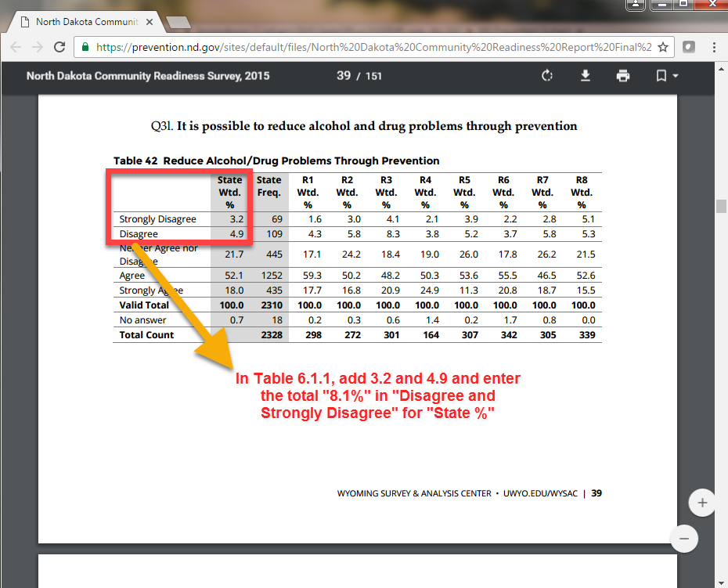

The State Epidemiological Outcomes Workgroup (SEOW) is a group of data experts and prevention stakeholders whose mission is to identify, analyze and communicate key substance abuse and related behavioral health data to guide programs, policies and practices. More information on ND’s SEOW and the products produced by the group are available here: [www.prevention.nd.gov/data](http://www.prevention.nd.gov/data). On product of the ND SEOW is the Substance Use North Dakota (SUND) data website: [www.sund.nd.gov](http://www.sund.nd.gov).

It is also important to gather and review existing information from previously conducted assessments.

##### Data Review

General Support For Prevention

### Complete the table below with results from the North Dakota Community Readiness Survey (ND CRS). Refer to table 4.2 of this workbook to identify the HSC Region that encompasses your community service area.

*ND CRS 2015: Table 42 – Page 39 (State and Region)*

|  |  |  |
| --- | --- | --- |
| It is possible to reduce alcohol and drug problems through prevention. | | |
|  | HSC* Region % | State % |
| Disagree and Strongly Disagree |  |  |
| Neither Agree nor Disagree |  |  |
| Agree and Strongly Agree |  |  |
| **Valid total** |  |  |
| *No answer* |  |  |

*\*HSC = Human Service Center*

### Complete the table below with results from the North Dakota Community Readiness Survey (ND CRS).

*ND CRS 2015: Table 81 – Page 59 (State and Region)*

|  |  |  |
| --- | --- | --- |
| Preventing alcohol and other drug use among youth is important. | | |
|  | HSC Region % | State % |
| Disagree and Strongly Disagree |  |  |
| Neither Agree nor Disagree |  |  |
| Agree and Strongly Agree |  |  |
| **Valid total** |  |  |
| *No answer* |  |  |

### Complete the table below with results from the North Dakota Community Readiness Survey (ND CRS).

*ND CRS 2015: Table 43 – Page 40 (State and Region)*

|  |  |  |
| --- | --- | --- |
| Alcohol and other drug prevention programs are a good investment because they save lives and money. | | |
|  | HSC Region % | State % |
| Disagree and Strongly Disagree |  |  |
| Neither Agree nor Disagree |  |  |
| Agree and Strongly Agree |  |  |
| **Valid total** |  |  |
| *No answer* |  |  |

### In a paragraph or more, analyze and explain the community’s support for prevention based on the data reviewed above (Tables 6.1.1 - 6.1.3).

|  |
| --- |
|  |

### Describe some unique behaviors and contexts specific to your community that impacts the overall support for prevention (including any local conditions that may reduce support for prevention).

|  |
| --- |
|  |

Community Prevention Efforts

### Complete the table below with results from the North Dakota Community Readiness Survey (ND CRS).

*ND CRS 2015: Table 82 – Page 59 (State and Region)*

|  |  |  |
| --- | --- | --- |
| I am concerned about whether my community has sufficient alcohol and other drug abuse prevention programs. | | |
|  | HSC Region % | State % |
| Disagree and Strongly Disagree |  |  |
| Neither Agree nor Disagree |  |  |
| Agree and Strongly Agree |  |  |
| **Valid total** |  |  |
| *No answer* |  |  |

### Complete the table below with results from the North Dakota Community Readiness Survey (ND CRS).

*ND CRS 2015: Table 86 – Page 61(State and Region)*

|  |  |  |
| --- | --- | --- |
| My community is taking strong action to prevent the misuse of alcohol and other drugs. | | |
|  | HSC Region % | State % |
| Disagree and Strongly Disagree |  |  |
| Neither Agree nor Disagree |  |  |
| Agree and Strongly Agree |  |  |
| **Valid total** |  |  |
| *No answer* |  |  |

### Complete the table below with results from the North Dakota Community Readiness Survey (ND CRS).

*ND CRS 2015: Table 85 – Page 61(State and Region)*

|  |  |  |
| --- | --- | --- |
| My community is actively instituting policies that address the misuse of alcohol and other drugs. | | |
|  | HSC Region % | State % |
| Disagree and Strongly Disagree |  |  |
| Neither Agree nor Disagree |  |  |
| Agree and Strongly Agree |  |  |
| **Valid total** |  |  |
| *No answer* |  |  |

### Complete the table below with results from the North Dakota Community Readiness Survey (ND CRS).

*ND CRS 2015: Table 83 – Page 60 (State and Region)*

|  |  |  |
| --- | --- | --- |
| There are leaders in my community who are interested in reducing access and abuse of alcohol and other drugs. | | |
|  | HSC Region % | State % |
| Disagree and Strongly Disagree |  |  |
| Neither Agree nor Disagree |  |  |
| Agree and Strongly Agree |  |  |
| **Valid total** |  |  |
| *No answer* |  |  |

### Complete the table below with results from the North Dakota Community Readiness Survey (ND CRS).

*ND CRS 2015: Table 44 – Page 40 (State and Region)*

|  |  |  |
| --- | --- | --- |
| The community has the responsibility to set up prevention programs to help people avoid alcohol and other drug problems. | | |
|  | HSC Region % | State % |
| Disagree and Strongly Disagree |  |  |
| Neither Agree nor Disagree |  |  |
| Agree and Strongly Agree |  |  |
| **Valid total** |  |  |
| *No answer* |  |  |

### Complete the table below with results from the North Dakota Community Readiness Survey (ND CRS).

*ND CRS 2015: Table 41 – Page 39 (State and Region)*

|  |  |  |
| --- | --- | --- |
| Schools need to be more active in dealing with alcohol, tobacco and other drug problems. | | |
|  | HSC Region % | State % |
| Disagree and Strongly Disagree |  |  |
| Neither Agree nor Disagree |  |  |
| Agree and Strongly Agree |  |  |
| **Valid total** |  |  |
| *No answer* |  |  |

### In a paragraph or more, analyze and explain the perception of community prevention efforts based on the data you reviewed above (Tables 6.1.6 - 6.1.11).

|  |
| --- |
|  |

### Describe some unique behaviors and contexts specific to your community that impacts the overall support for prevention.

|  |
| --- |
|  |

##### Summary – Community Readiness

### In a paragraph or more, provide a summary of your community’s readiness to address underage drinking. To the best of your knowledge, identify your service area’s stage of readiness and why you came to that conclusion (review community readiness stages below).

|  |
| --- |
|  |

**COMMUNITY READINESS STAGES**

* **Stage 1 – Community Tolerance / No Knowledge:** The community or leaders do not generally recognize substance abuse as a problem. “It’s just the way things are” is a common attitude. Community norms may encourage or tolerate the behavior in social contexts. Substance abuse may be attributed to age, sex, racial, or class groups.
* **Stage 2 – Denial:** There is some recognition by at least some members of the community that the behavior is a problem, but little or no recognition that it is a local problem. Attitudes may include, “It’s not my problem” or “We can’t do anything about it.”
* **Stage 3 – Vague Awareness:** There is a general feeling among some in the community that there is a local problem and that something ought to be done, but there is little motivation to do anything. Knowledge about the problem is limited. No identifiable leadership exists, or leadership is not encouraged.
* **Stage 4 – Preplanning:** There is clear recognition by many that there is a local problem and something needs to be done. There is general information about local problems and some discussion. There may be leaders and a committee to address the problem, but no real planning or clear idea or how to progress.
* **Stage 5 – Preparation:** the community has begun planning and is focused on practical details. There is general information about local problems and about the pros and cons of prevention programs, but this information may not be based on formally collected data. Leadership is active and energetic. Decisions are being made and resources (time, money, people, etc.) are sought and allocated.
* **Stage 6 – Initiation:** Data are collected that justify a prevention program. Decisions may be based on stereotypes rather than data. Action has just begun. Staff is being trained. Leaders are enthusiastic, as few problems or limitations have occurred.
* **Stage 7 – Institutionalization / Stabilization:** Several planned efforts are underway and supported by community decision makers. Programs and activities are seen as stable, and staff is trained and experienced. Few see the need for change or expansion. Evaluation may be limited, although some data are routinely gathered.
* **Stage 8 – Confirmation / Expansion:** Efforts and activities are in place and community members are participating. Programs have been evaluated and modified. Leaders support expanding funding and program scope. Data are regularly collected and used to drive planning.



### Assessing ***Coalition*** Readiness

### In the table below, please estimate the coalition’s level of knowledge in each of the areas listed. Please place an “X” in the boxes to indicate your responses. This tool will help you identify the coalition’s level of readiness, and identify where their capacity needs to be increased.

|  |  |  |  |
| --- | --- | --- | --- |
| ***1 = Not very knowledgeable*** | ***2 = A little knowledgeable*** | ***3 = Somewhat knowledgeable*** | ***4 = Very knowledgeable*** |

|  |  |  |  |  |
| --- | --- | --- | --- | --- |
|  | **1** | **2** | **3** | **4** |
| **The Strategic Prevention Framework** |  |  |  |  |
| **Substance abuse prevention** |  |  |  |  |
| **Ensuring cultural competence in implementation** |  |  |  |  |
| **Evidence-based prevention strategies** |  |  |  |  |
| **Adaptation of strategies** |  |  |  |  |
| **Action planning for implementation** |  |  |  |  |
| **Ensuring sustainability in implementation** |  |  |  |  |
| **Logic models** |  |  |  |  |
| **Identification of indicators for evaluation** |  |  |  |  |
| **Identification of data sources for evaluation** |  |  |  |  |
| **Data collection for evaluation** |  |  |  |  |
| **Data analysis** |  |  |  |  |
| **Reporting evaluation data** |  |  |  |  |

### In a paragraph or more, summarize the areas indicated above where the coalition excels and areas the coalition needs to build knowledge. Identify the steps that can be taken to enhance knowledge in these areas.

|  |
| --- |
|  |

Assess the Problem

# Stakeholder Meetings

Coalitions that engage openly with stakeholders that may have a direct investment to underage drinking prevention have a higher likelihood of successful community change. Fostering relationships with stakeholders at this stage of the project also encourages both trust in the process and community buy-in and support, not only of the assessment, but of whatever actions are taken as a result of it.

Prior to moving forward with the following sections in this workbook, you will be conducting in-person meetings with key community stakeholders within your service area. These meetings will not only assist you and your coalition in identifying stakeholders with valuable insights about underage drinking in each community you serve, but will also assist in fostering relationships with these stakeholders early in the PFS project.

You are required to have meetings with individuals representing four primary community sectors (see the full list of community sectors on the next page): *Law Enforcement, Local/Tribal Government, Education*, and *Youth*. Once your coalition identifies the individuals from each sector, you will schedule in-person meetings to engage in guided conversation about underage drinking. The questions provided in this section will guide this informal process, which will provide your coalition with valuable information for this workbook and for strategic planning.

Please reach out to the Training and Technical Assistance staff to connect you with resources and tools if you would like further assistance in connecting with identified stakeholders.

* 1. Complete the tables below to identify the stakeholders you met with.

You are required to conduct meetings with representatives from each community within your service area (i.e. counties, towns, sectors) for the following sectors:

**Local law enforcement official** from each law enforcement agency (Police / Sheriff) in your service area.

*Ex: If there are five towns in your service area, but only one sheriff’s department and one police department, you would meet with two individuals.*

|  |  |  |
| --- | --- | --- |
| **Law Enforcement Agency Name** | **Stakeholder Name and Title** | **Date of Meeting** |
|  |  |  |
|  |  |  |
|  |  |  |
|  |  |  |

**Governmental leader** (City Council member, Tribal Council member, County Commissioner) from each governing body in your service area.

*Ex: If there are five towns in your service area, interview one person from each respective city council; only one interview is needed from Tribal representation.*

|  |  |  |
| --- | --- | --- |
| **Governing Body Name** | **Stakeholder Name and Title** | **Date of Meeting** |
|  |  |  |
|  |  |  |
|  |  |  |
|  |  |  |

**School or education representative** from each middle school and high school in your service area.

*Ex: If there are five schools with combined middle school and high schools located within your service area, you would meet with five individuals. If there are five middle schools and five high schools within your service area, you would meet with 10 individuals.*

|  |  |  |
| --- | --- | --- |
| **School Name** | **Stakeholder Name and Title** | **Date of Meeting** |
|  |  |  |
|  |  |  |
|  |  |  |
|  |  |  |

**Youth representative** living in each community within your service area (Ages 18-21).

*Recommendation: If there are rural county areas as well as towns within your service area, make attempts to meet with a youth representing both.*

|  |  |
| --- | --- |
| **Stakeholder Name and Title** | **Date of Meeting** |
|  |  |
|  |  |
|  |  |
|  |  |

These four sectors represent the minimum meetings that need to occur within your service area. You may schedule additional meetings with representation from other sectors if you so choose.

Here is a list of all sectors (The four required sectors are in **bold**):

**Community Sectors** *(\**[*Drug Free Community Grant*](http://www.samhsa.gov/grants/grant-announcements/sp-14-002) *[a community grant opportunity offered through SAMHSA] required sectors)*

* Businesses*
* Child Care Providers
* Civic/Volunteer Groups*
* Courts & Probation
* Cultural Groups and Organizations
* Elementary/**Secondary Education\***
* **Government\***
* Healthcare Professionals*
* Higher Education
* Human and Social Service Providers
* **Law Enforcement\***
* Media*
* Parents*
* Religious/Fraternal Organizations*
* Senior Citizens
* **Youth\***
* Youth Serving Organizations*
* Others*

#### Recruiting Participants

You are encouraged to work with your agency and coalition to identify the specific individuals from these sectors you need to contact. After identifying the appropriate people to talk to, you will need to contact each person individually by phone, email, or in-person (preferred) to ask if they will be willing to meet with you. Let them know the meeting is expected to take about an hour and is very informal. In fact, you can meet over coffee if that works best. If they agree to participate, work with them to schedule a time and place to meet in person.

The following example scripts may be used to invite people to meet with you. You are not required to use these scripts, but they may assist in knowing the types of information to share when making contact to schedule a meeting.

Phone Script:

“Hello, (insert name of community member) this is (insert name), with (insert name of organization). Recently, we have been awarded a grant from the North Dakota Department of Human Services called the Strategic Prevention Framework Partnership for Success. This grant is aimed at prevention of underage alcohol use, and in order to gain a better understanding of our community, we are hoping to meet with valuable stakeholders that may have knowledge about this topic and an important perspective. The (insert coalition, workgroup, agency) that I work with has identified you *as someone with a valuable perspective on this topic*. Would you be willing to meet with me to discuss underage alcohol use in your community? The meeting would last about one hour and is very informal. I am looking at XXXX dates. Do any of those days work for you? (proceed with scheduling time, date, location). If at all possible, I would like to meet with you in-person at your office or another location of your choosing. Closing: If yes to meeting: Thank you for your willingness to assist with this project. I will see you on (Date) at (Time). If No to meeting: Okay, Do you know of anyone else that may be interesting in meeting with me? Thank you for your time.”

Email Script:

“Dear (insert contact name): My name is (insert name) and recently my organization has been awarded a grant aimed at preventing underage drinking, the Strategic Prevention Framework Partnership for Success. As part of this project, we are hoping to meet with stakeholders that may have a valuable perspective about our community. The (insert coalition, workgroup, agency) that I work with identified you as someone with a valuable perspective. If you are interested, please give me a call back, and I will provide you with more details and we can schedule a time to meet. My number is (701) XXX-XXXX. Thank you and I look forward to hearing from you soon. Sincerely, (insert your name and title)”

#### Example Meeting Questions

The questions below are provided as a guide to use when meeting with your identified individuals. While your meetings are meant to be informal, it’s important you guide the meeting in order to capture useful information. You may use all questions provided or only selected ones, but keep in mind that the compilation of all questions will provide you with valuable information to assist with assessing the problem, intervening variables, and local conditions present in your service area. Use these questions to have purposeful conversations when meeting with identified stakeholders.

It is recommended to take notes to document the conversation in order to utilize the information when completing the following section.

UNDERAGE ALCOHOL USE AND CONSEQUENCES

When identifying consumption and consequences in your service area, the questions should get at the population of those underage drinking, and the times, locations, and quantity of their consumption. Questions should also aim to identify information about any negative outcomes that may be resulting from underage drinking in your service area such as crashes, injuries, or legal consequences.

* What types of alcohol are being consumed?  Beer, wine, liquor, alcopops, kegs?
* When are they drinking?  After school, at school, weekends, around sporting events?
* Where are they drinking?  At home, at parties, social gatherings?
* How much are they drinking?
* Are there any specific occasions that they are drinking? Graduation parties, family celebrations, wedding dances, public gatherings?
* What consequences do we see of underage drinking?
  + Health? Safety? (drownings, injuries, assaults, vehicle crashes), Financial? Educational? Legal?  Professional? Employment?

INTERVENING VARIABLES AND LOCAL CONDITIONS

When identifying Intervening Variables (“but why”) and local conditions (“but why here?”) the questions should get at the context /environment in which the drinking occurs.  The questions should be collected to identify local conditions that are specific, identifiable and actionable.

**Retail Availability:**

* Are stores selling alcohol to minors?
* Are they checking ID’s?
* Are store owners and staff trained in Responsible Beverage Server Training?
* Are compliance checks conducted?
* What happens to those retailers who fail?  Who pass?
* Are youth stealing alcohol from stores?  Which ones?

**Social Availability:**

* How are youth getting alcohol from non-retailer (social) sources?
* Who is providing the alcohol?  Friends, siblings, parents, strangers? When, under what conditions?  Are they special occasions when this occurs?
* Are youth standing outside retailers and asking adults to buy?
* Are youth getting alcohol at local colleges?  Are they attending parties?  Which ones?
* Are parents providing or just not monitoring?
* Do youth have access at family or community events?

**Laws/Policies and Enforcement:**

* What laws or policies are in place related to underage drinking?
* What is the perception of enforcement of these laws in the community?
* How much support is provided to law enforcement by the community to support the laws?
* Are the laws adjudicated?  What is the follow up to an arrest or citation?
* Do youth perceive that laws are a) in place?  b) enforced and c) adjudicated?

**Community Norms:**

* Is alcohol associated with community events?
* What are norms in the community related to alcohol?
* What is the exposure of young people to these norms?  Advertising?
* How is alcohol promoted as part of community events?  Public events? Private events?
* Are there “rites of passages” in the community that involve alcohol? What are they?  Do youth see them?

# Underage Drinking: Consequences

Consequences are defined as the social, economic and health problems associated with the use of alcohol and illicit drugs. Examples are things such as illnesses related to alcohol (cirrhosis, fetal effects), drug overdose deaths, crime, and car crashes or suicides related to alcohol or drugs. Alcohol-related consequences are defined as the social, economic, and health problems associated with the use of alcohol. This section looks at consequences associated with underage drinking, which will help you consider the magnitude and extent of these problems in your community.

##### Data Sources/Resources

The Youth Risk Behavior Survey (YRBS) was developed in 1990 by the Centers for Disease Control and Prevention (CDC) to monitor priority health risk behaviors that contribute markedly to the leading causes of death, disability and social problems among youth and adults in the United States. North Dakota began participating in the YRBS survey in 1995. Students in grades 7-8 and 9-12 are surveyed in the spring of odd years. The survey is voluntary and completely anonymous.

The North Dakota survey is administered biennially in late winter/early spring of odd years through the Department of Public Instruction.

* The North Dakota YRBS results (results are available statewide and by Regional Education Association region) are available here: <https://www.nd.gov/dpi/SchoolStaff/SafeHealthy/YRBS/>.

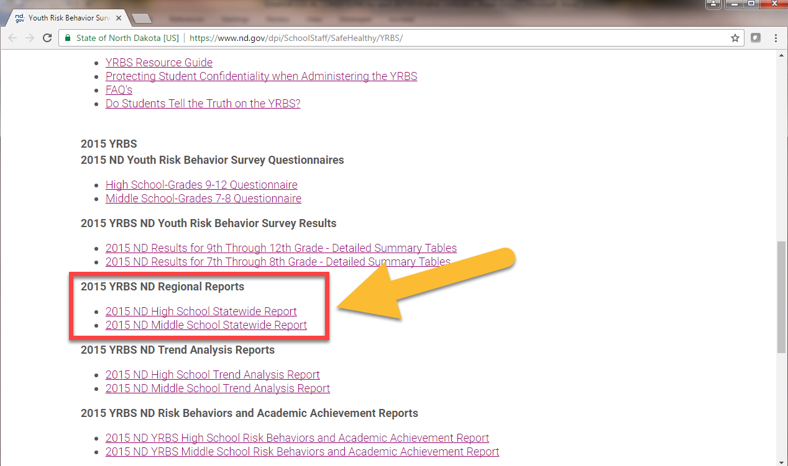

* The National YRBS results are available here: <https://nccd.cdc.gov/Youthonline/App/Default.aspx>.

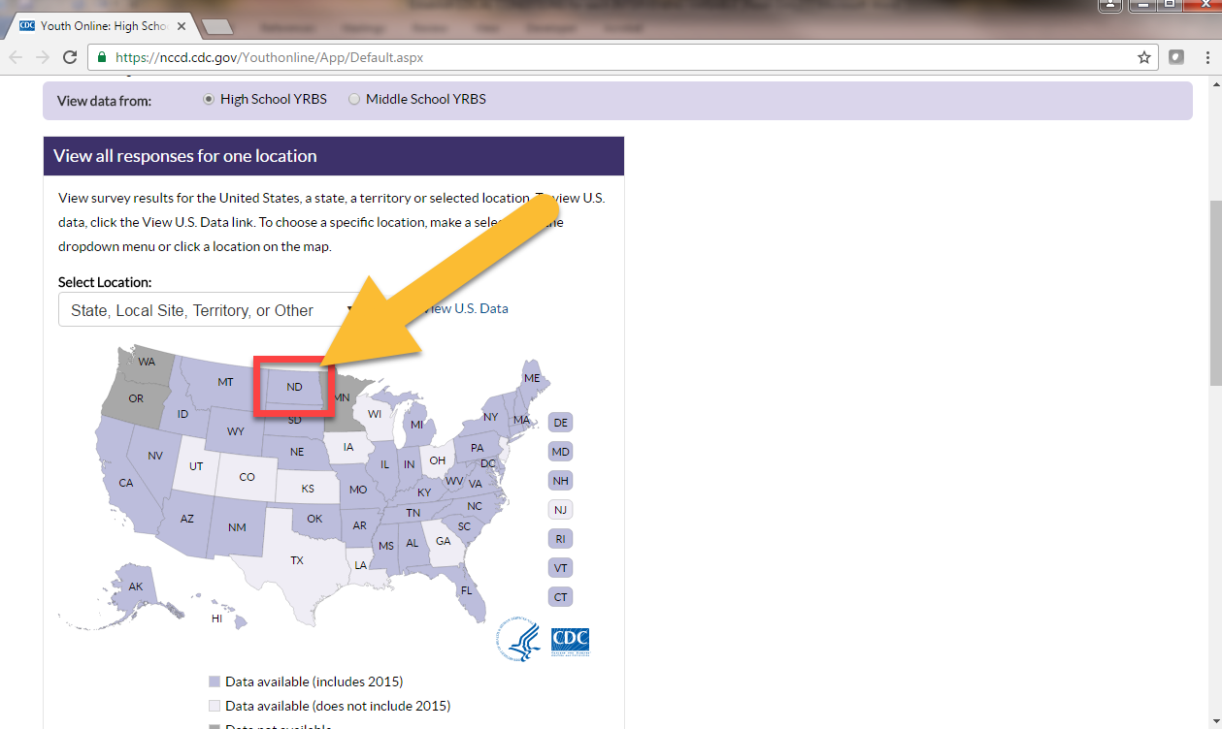

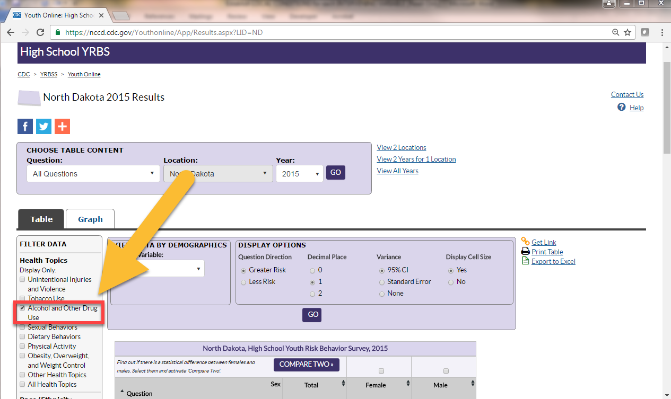

The Crime in North Dakota report is an annual report released by the Attorney General and includes crime (violent and property) and arrest analyses, including drug and alcohol arrests. The report is available here: <https://www.ag.nd.gov/Reports/BCIReports/CrimeHomicide/CrimeHomicide.htm>

The North Dakota Crash Summary is an annual report released by the ND Department of Transportation describing the trends and effects of traffic crashes in North Dakota, including alcohol-related crashes, injuries and fatalities. The data for this summary is derived from North Dakota crash reports. These reports are completed by law enforcement officers throughout the state who collect data from crash scenes on public roadways. Information is collected when a crash involves fatalities, injuries, or at least $1,000 property damage. Crash reports are forwarded to NDDOT for central collection. NDDOT reviews the crash report forms and enters the data into a database called the Crash Reporting System (CRS). The report is available here: <http://www.dot.nd.gov/divisions/safety/trafficsafety.htm>.

The State Epidemiological Outcomes Workgroup (SEOW) is a group of data experts and prevention stakeholders whose mission is to identify, analyze and communicate key substance abuse and related behavioral health data to guide programs, policies and practices. More information on ND’s SEOW and the products produced by the group are available here: [www.prevention.nd.gov/data](http://www.prevention.nd.gov/data). On product of the ND SEOW is the Substance Use North Dakota (SUND) data website: [www.sund.nd.gov](http://www.sund.nd.gov).

It is also important to gather and review existing information from previously conducted assessments.

##### Data Review

Regarding alcohol-related consequences the YRBS asks two questions:

* How many days during the past month have you ridden with someone who had been drinking alcohol?
* How many days during the past month have you driven a car or other vehicle when you have been drinking alcohol?

In order to fully complete the data review for this section, you will need to request the YRBS results from the High Schools in your service area who participated in the survey. If you are unable to obtain the YRBS results for the High Schools in your service area, note this as a data gap in question 8.5, and include an explanation of why the data was not available (example: high school did not participate in YRBS, high school administration refused to share results, etc.). If your service area has more than one school, copy and paste the table (or insert additional columns) below for each school.

* 1. Complete the table below with results from the Youth Risk Behavior Survey (YRBS). Refer to table 4.3 in this workbook to identify the REA that encompasses your community service area.

*North Dakota High School YRBS 2015: page 4,* [*https://www.nd.gov/dpi/SchoolStaff/SafeHealthy/YRBS/*](https://www.nd.gov/dpi/SchoolStaff/SafeHealthy/YRBS/)

*National High School YRBS 2015:* [*https://nccd.cdc.gov/Youthonline/App/Default.aspx*](https://nccd.cdc.gov/Youthonline/App/Default.aspx)

*ND SPF SIG Community Final Evaluation Report: Figure 3 – Page 10*

|  |  |  |  |  |
| --- | --- | --- | --- | --- |
| Summary of high School Student Alcohol Consequences | | | | |
|  | **Local School**  Name: | **Region**  REA: | **State** | **National** |
| Rode in a car |  |  |  |  |
| Drove a car |  |  |  |  |

* 1. Analyze and explain the underage alcohol consequence data including a comparison between your local school(s), region, state and national rates. Also, include a comment about the trend found in “Figure 3: Youth Drinking and Driving Behaviors” (Rode in a Car; Drove a Car) in your community’s SPF SIG Final Evaluation Report. (Use 3 sentences or more)

|  |
| --- |
|  |

* 1. Is any of the underage alcohol consequence data available by grade, gender, and/or race/ethnicity for your local school(s)? If so, describe any differences that you find. If this data is not available, state that it is not available.

|  |
| --- |
|  |

* 1. Complete the table below summarizing juvenile alcohol-related arrests in your service area for the calendar year 2015 (to calculate percent, take the number of DUI arrests or liquor law arrests and divide by the total number of juvenile arrests, then multiply by 100).

*North Dakota Uniform Crime Report:* <https://www.ag.nd.gov/Reports/BCIReports/CrimeHomicide/CrimeHomicide.htm>

|  |  |  |  |  |  |
| --- | --- | --- | --- | --- | --- |
| **Police/Sheriff Office** | **Total Number Juvenile Arrests** | **Juvenile DUI Arrests** | | **Juvenile Liquor Law Violation Arrests** | |
| **Number** | **Percent** | **Number** | **Percent** |
|  |  |  |  |  |  |
|  |  |  |  |  |  |
|  |  |  |  |  |  |

* 1. Analyze and explain any other underage drinking consequence data available for your service area (school suspensions/expulsions, crime/arrests, [costs of underage drinking](http://www.pire.org/documents/UDETC/cost-sheets/ND.pdf), suicides related to alcohol use, hospital ER, treatment, etc.).

|  |
| --- |
|  |

* 1. Describe any data gaps related to underage drinking consequence data. What information were you not able to obtain? How would that information help inform your prevention efforts?

|  |
| --- |
|  |

##### Summary – Underage Drinking Consequences

* 1. Review all the information gathered above (Section 8) and provide a paragraph or more summarizing the underage drinking consequences in your service area. Include a description of differences between towns and/or county(s)/segments within your service area.

|  |
| --- |
|  |

# 

# Underage Drinking: Consumption

To understand the magnitude of substance use consequences it is important to understand the substance use, or consumption, itself. Consumption is comprised of both the amount and frequency at which a person consumes alcohol; for instance, a consumption measurement might be the percentage of individuals who had at least one drink of alcohol on one or more days during the past month. It is also important to understand when drinking becomes binge drinking. For the purposes of most of the data sources used in this workbook, binge drinking is defined for women as consuming four or more alcoholic drinks on a single occasion and defined for men as consuming five or more alcoholic drinks on a single occasion.

##### Data Sources/Resources

You will review the Youth Risk Behavior Survey again in this section (refer to Section 8). Another data source to consider is the National Survey on Drug Use and Health (NSDUH) is an annual nationwide survey involving interviews with approximately 70,000 randomly selected individuals aged 12 and older. This annual survey is conducted by Substance Abuse and Mental Health Services Administration (SAMHSA) and includes measures on alcohol, tobacco, and other drug use/abuse – including prescription drugs – and mental health in the US. Reports are released annually and, at the state level, consist of 2-year averages with about a 2-year lag in data (e.g., 2011-2012 state average data was released in 2014). Data can be found here: <http://www.samhsa.gov/data/population-data-nsduh/reports?tab=38>

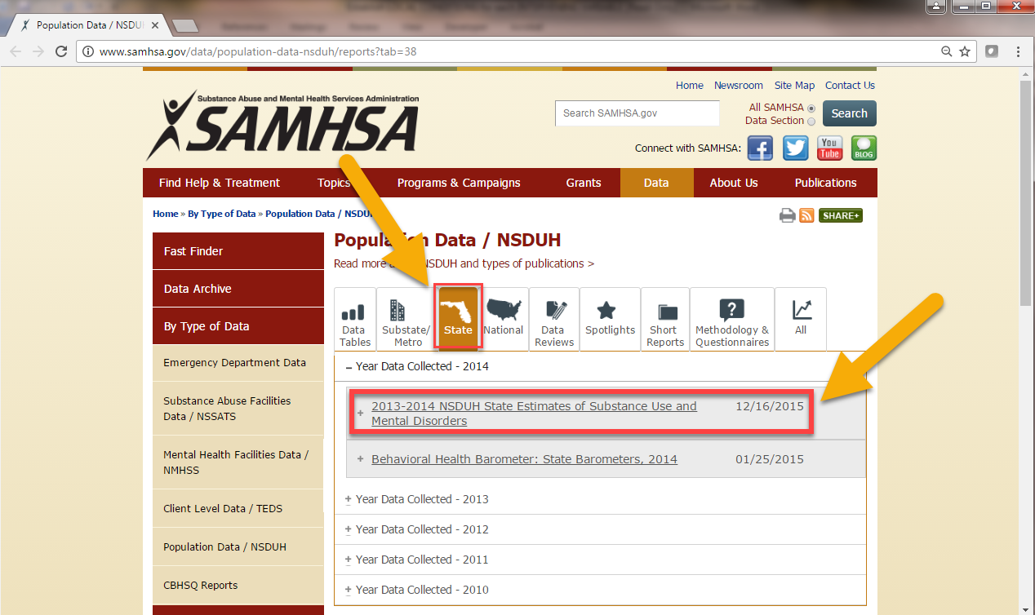

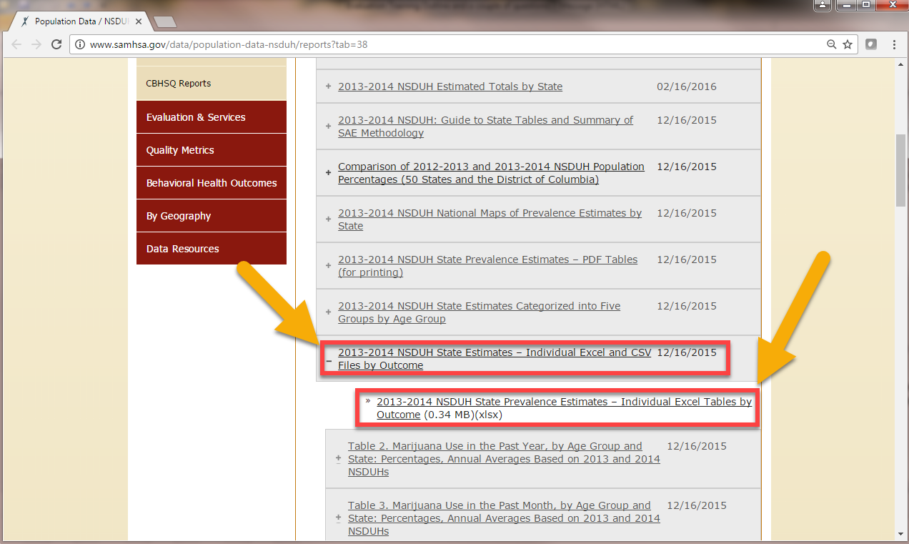

##### Data Review

In order to fully complete the data review for this section, you will need to request the YRBS results from the High Schools in your service area who participated in the survey. If you are unable to obtain the YRBS results for the High Schools in your service area, note this as a data gap in question 9.7, and include an explanation of why the data was not available (example: high school did not participate in YRBS, high school administration refused to share results, etc.). If your community area has more than one school, copy and paste the table (or insert additional columns) below for each school.

* 1. Complete the table below with results from the Youth Risk Behavior Survey (YRBS).

*North Dakota Middle School YRBS 2015: page 6,* [*https://www.nd.gov/dpi/SchoolStaff/SafeHealthy/YRBS/*](https://www.nd.gov/dpi/SchoolStaff/SafeHealthy/YRBS/)*.*

*National Middle School YRBS 2015:* [*https://nccd.cdc.gov/Youthonline/App/Default.aspx*](https://nccd.cdc.gov/Youthonline/App/Default.aspx)

|  |  |  |  |  |
| --- | --- | --- | --- | --- |
| Summary of Middle School Student Alcohol Consumption | | | | |
|  | **Local School**  Name: | **Region**  REA: | **State** | **National** |
| **Lifetime Alcohol Use**  *Percentage of students who ever drank alcohol (other than a few sips)* |  |  |  |  |
| **Lifetime Binge Alcohol Use** |  |  |  |  |
| **First Use Before Age 11** |  |  |  |  |

* 1. Complete the table below with results from the Youth Risk Behavior Survey (YRBS).

*ND SPF SIG Community Final Evaluation Report: Figure 4 – Page 11*

*North Dakota High School YRBS 2015: page 8,* [*https://www.nd.gov/dpi/SchoolStaff/SafeHealthy/YRBS/*](https://www.nd.gov/dpi/SchoolStaff/SafeHealthy/YRBS/)*.*

*National High School YRBS 2015:* [*https://nccd.cdc.gov/Youthonline/App/Default.aspx*](https://nccd.cdc.gov/Youthonline/App/Default.aspx)

|  |  |  |  |  |
| --- | --- | --- | --- | --- |
| Summary of High School Student Alcohol Consumption | | | | |
|  | **Local School**  Name: | **Region**  REA: | **State** | **National** |
| **Lifetime Alcohol Use** |  |  |  |  |
| **Current Alcohol Use**  (past 30-days) |  |  |  |  |
| **Current Binge Alcohol Use**  (past 30-days) |  |  |  |  |
| **First Use Before Age 13** |  |  |  |  |

The next table (9.3) will provide the information needed to support your focus on underage drinking.

* 1. Complete the table below with results from the Youth Risk Behavior Survey (YRBS).

*North Dakota High School YRBS 2015: page 6, 8 & 9,* [*https://www.nd.gov/dpi/SchoolStaff/SafeHealthy/YRBS/*](https://www.nd.gov/dpi/SchoolStaff/SafeHealthy/YRBS/)*.*

*National High School YRBS 2015:* [*https://nccd.cdc.gov/Youthonline/App/Default.aspx*](https://nccd.cdc.gov/Youthonline/App/Default.aspx)

|  |  |  |  |  |
| --- | --- | --- | --- | --- |
| Comparison of Lifetime Substance Use among High School Students | | | | |
|  | **Local School**  Name: | **Region**  REA: | **State** | **National** |
| **Lifetime Alcohol Use** |  |  |  |  |
| **Lifetime Cigarette Use** |  |  |  |  |
| **Lifetime Cocaine Use** |  |  |  |  |
| **Lifetime Ecstasy Use** |  |  |  |  |
| **Lifetime Heroin Use** |  |  |  |  |
| **Lifetime Over-the-Counter Drug Misuse** |  |  |  |  |
| **Lifetime Prescription Drug Misuse** |  |  |  |  |
| **Lifetime Synthetic Drug Use** |  |  |  |  |

*\*Lifetime marijuana use was not asked in the 2015 YRBS*

* 1. Analyze and explain the underage alcohol consumption data including a comparison between your local school(s), region, state and national rates. Also, include a comment about the trend found in “Figure 4: Youth Drinking Rate” (At least one drink; Five or more drinks in a row) in your community’s SPF SIG Final Evaluation Report. (Use 3 sentences or more)

|  |
| --- |
|  |

* 1. Is any of the underage alcohol consumption data available by grade, gender, and/or race/ethnicity for your local school(s)? If so, describe any differences that you find. If this data is not available, state that it is not available.

|  |
| --- |
|  |

* 1. Summarize any other underage drinking consumption data available for your service area (Core Survey, National Survey on Drug Use and Health, etc.).

|  |
| --- |
|  |

* 1. Describe any data gaps related to underage drinking consumption data. What information were you not able to obtain? How would that information help inform your prevention efforts?

|  |
| --- |
|  |

##### Summary – Underage Drinking Consumption

* 1. Review all the information gathered above (Section 9) and provide a paragraph or more summarizing the underage drinking consumption in your service area. Include a description of differences between towns and/or county(s)/segments within your service area.

|  |
| --- |
|  |

# Developing a Problem Statement

By now, you have a pretty good idea of the consequences and consumption patterns available for underage drinking in your community based on the information you have collected. In the Strategic Prevention Framework, substance‐related consequences are defined as the social, economic, and health problems associated with the use of alcohol and illicit drugs. In essence, consequences and related consumption patterns are your problem statements.

A problem statement is usually one or two sentences to explain the problem your efforts will address. In general, a problem statement will outline the negative points of the current situation and explain why this matters. It also serves as a great communication tool, helping to get buy in and support from others.

Effective problem statements:

* Identify one issue or problem at a time.
* Avoid blame. (E.g. the problem is “young people in our neighborhood do not have enough positive activities” rather than “the kids in Belmont have nothing to do and are trouble makers.”)
* Avoid naming specific solutions. (e.g. the problem is not “we don’t have a youth center”– the problem may be “young people in our neighborhood are getting into trouble during after-school hours” for which a new youth center may be one element of an overall solution.)
* Are specific enough to be measurable.
* Reflect community concerns as heard during the assessment process.
  1. Review Table 8.7 (summary of underage drinking consequences) and Table 9.8 (summary of underage drinking consumption) and create a problem statement summarizing the issue you plan to address in the PFS project. This problem statement is what will be added to the “Problem” column of your community logic model (highlighted below).

|  |
| --- |
|  |

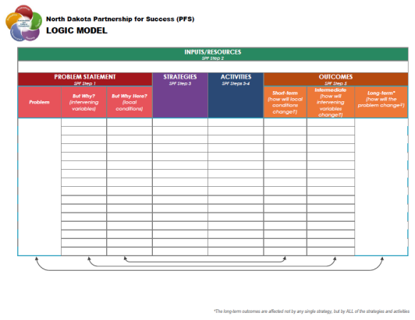

# Why Underage Drinking in My Community: Intervening Variables

Like a doctor, the goal is to understand the cause of the symptoms and attack the source—remember crime and drug abuse are symptoms. We analyze problems and goals to surface root causes. The theory behind outcomes based prevention is that there are factors that “cause” substance-related consequences and consumption in communities. We call these factors intervening variables. The “but why” technique is a great exercise for identifying these intervening variables related to the problem (substance-related consequences and consumption in communities). It is through positively impacting intervening variables that we achieve population-level changes in substance consumption and consequences. The North Dakota PFS project focuses on the top four intervening variables identified through the SPF SIG community needs assessment prioritization:

Intervening Variables = But Why?

Local Conditions/ Contributing Factors = But Why Here?

* **Retail Availability**
* **Social Availability**
* **Community Norms**
* **Enforcement**

Most answers to the but why exercise could be equally applied to any community—these are the generic intervening variables (causes). By asking “but why here?” your coalition can better identify and address how a root cause manifests itself in your community. Only local people or those familiar with the local context can truly answer the “But why here?” portion of this exercise. This technique requires your community to examine the data and information gathered during the assessment process and helps identify what additional data are needed. If the underlying factors were the same in every community, there would be no need for local community coalitions. The “but why here” exercise will compel your coalition to select strategies and initiatives that get to the unique root causes of substance abuse in your community.

Local conditions (the “but why here?”) must be:

* **Specific** – represents a behavior that occurs in the community – not an attitude or belief. (Not an intervening variable.) The local condition describes where, when, and on what occasions the behavior occurs.
* **Identifiable** – the behavior can be “seen” or observed by community members and occurs often enough to be measured in some way.
* **Actionable** – the behavior can be changed through the implementation of targeted strategies by the coalition and its community partners.

##### Data Sources/Resources

You will again review the North Dakota Community Readiness Survey (CRS) in this section (refer to Section 6.1). Another resource to review in order to assess intervening variables and local conditions is your community alcohol policies. It is also important to gather and review existing information from previously conducted assessments.



## Retail Availability

Alcohol is a product that requires a retail market. The easier it is to obtain alcohol through that market, the greater the consumption. Research shows that access restrictions are related to lower consumption rates and decreases in associated problems. The table below displays some example local conditions (the “but why here?”) related to retail availability.

|  |  |
| --- | --- |
| **Examples of Local Conditions** *(Contributing Factors)* **for Retail Availability** | |
| ID issues | Use of fake IDs; failure of retailers to properly check IDs |
| Compliance with laws and regulations | Sales to minors; bootlegging; sales to intoxicated persons |
| Density | High-density package sales locations; high-density open-container sales locations |
| Product characteristics | Forty-ounce containers; keg registration tags are easy to remove; lack of lock caps on hard liquor bottles |
| Employees | Clerks have underage friends and sell to them |
| Product placement | Ease of shoplifting; alcohol placement in store; segregated sales; alcohol pops |
| Shoulder tapping | Youth approach an adult outside an alcohol establishment and ask the adult to purchase alcohol for them |

##### Data Review

Scan of Community Retail Availability

* + 1. How many liquor licenses are in your service area? Include a description of differences between towns and/or county(s)/segments within your service area if available.

To create the rate of people per liquor license, take the population of your service area and divide by the number of liquor licenses. This is the number of people per liquor license. Higher numbers indicate there are more people per liquor license, which means lower retail availability (higher numbers are better).

$$\frac{population}{\# of liquor licenses}=Number of people per license$$

*Refer to Appendix A for liquor license and population counts for the counties in your service area.*

|  |
| --- |
|  |

* + 1. Are there restrictions on the number of alcohol establishments that can be in your community? Describe these restrictions. Include a description of differences between towns and/or county(s)/segments within your service area.

|  |
| --- |
|  |

* + 1. Where are alcohol outlets and bars located (e.g., near schools, parks) in your community? Include a description of location differences between towns and/or county(s)/segments within your service area.

|  |
| --- |
|  |

* + 1. Are there restrictions on where alcohol establishments can be located (e.g., proximity to schools)? Describe these restrictions. Are the restrictions enforced? Include a description of restriction differences between towns and/or county(s)/segments within your service area.

|  |
| --- |
|  |

* + 1. In general, what days and hours are alcohol establishments open? Include a description of days/hours differences between towns and/or county(s)/segments within your service area.

|  |
| --- |
|  |

* + 1. Are there restrictions on the days and/or hours they can sell alcohol/be open? Describe these restrictions. Are the restrictions enforced? Include a description of restriction differences between towns and/or county(s)/segments within your service area.

|  |
| --- |
|  |

* + 1. Where else (e.g., concert venues, festivals, sporting events, other community events) is alcohol sold in your community? What kind of alcohol is sold at these places (tap beer, Mike’s Hard Lemonade, Wine, etc)? Include a description of differences between towns and/or county(s)/segments within your service area.

*Ask your city or county offices if they have the number of special events permits issued on average each year.*

|  |
| --- |
|  |

* + 1. Are there restrictions on special event permits in your community? Are there differences within different communities in your service area? Describe these restrictions. Are the restrictions enforced? Include a description of restriction differences between towns and/or county(s)/segments within your service area.

|  |
| --- |
|  |

* + 1. Analyze and explain the information you reviewed above regarding retail availability (Tables 11.1.1 – 11.1.8).

|  |
| --- |
|  |

Community Perception of Retail Availability

* + 1. Complete the table below with results from the North Dakota Community Readiness Survey (ND CRS).

*ND SPF SIG Community Final Evaluation Report: Figure 9 – Page 14*

*ND CRS 2015: Table 64 – Page 50 (State and Region)*

|  |  |  |
| --- | --- | --- |
| In your opinion, how difficult is it for youth in your community to buy beer, wine or hard liquor at stores themselves? | | |
|  | Region % | State % |
| Not at all difficult |  |  |
| Slightly difficult |  |  |
| Somewhat difficult |  |  |
| Quite difficult |  |  |
| Extremely difficult |  |  |
| **Valid total** |  |  |
| *Don’t know* |  |  |
| *No answer* |  |  |

* + 1. Complete the table below with results from the North Dakota Community Readiness Survey (ND CRS).

*ND SPF SIG Community Final Evaluation Report: Figure 9 – Page 14*

*ND CRS 2015: Table 66 – Page 51 (State and Region)*

|  |  |  |
| --- | --- | --- |
| In your opinion, how difficult is it for youth in your community to order a drink at a bar? | | |
|  | Region % | State % |
| Not at all difficult |  |  |
| Slightly difficult |  |  |
| Somewhat difficult |  |  |
| Quite difficult |  |  |
| Extremely difficult |  |  |
| **Valid total** |  |  |
| *Don’t know* |  |  |
| *No answer* |  |  |

* + 1. Analyze and explain the information you reviewed above (Tables 11.1.10 and 11.1.11).

|  |
| --- |
|  |

Readiness for Addressing Retail Availability

* + 1. Complete the table below with results from the North Dakota Community Readiness Survey (ND CRS).

*ND CRS 2015: Table 52 – Page 44 (State and Region)*

|  |  |  |
| --- | --- | --- |
| There should be a law requiring servers and bartenders at restaurants and bars to be specially trained on how to serve alcohol responsibly. | | |
|  | HSC Region % | State % |
| Disagree and Strongly Disagree |  |  |
| Neither Agree nor Disagree |  |  |
| Agree and Strongly Agree |  |  |
| **Valid total** |  |  |
| *No answer* |  |  |

* + 1. Analyze and explain the community support for server training (Table 11.1.13).

|  |
| --- |
|  |

##### Summary

* + 1. Summarize any other retail availability data available for your service area (news stories, review social media posts, key informant interviews, youth focus groups, compliance check passes/failures, etc.).

|  |
| --- |
|  |

* + 1. Describe some unique behaviors and contexts specific to your community that impacts retail availability (ask yourself, “But why here?”). Identify at least two of these local conditions. Include the data/sources (qualitative and/or quantitative) that support the identification of these local conditions.

*Utilize information gathered through stakeholder meetings conducted as part of Section 7. This information may provide qualitative support for the identification of local conditions.*

|  |
| --- |
|  |

* + 1. In a paragraph or more, describe how RETAIL AVAILABILITY is impacting underage drinking in your service area (utilizing the information you gathered above in section 11.1).

|  |
| --- |
|  |



## Social Availability

This refers to obtaining alcohol from unlicensed sources such as friends, family, or at a party without the exchange of money. Research indicates that underage youth primarily receive their alcohol through these sources, rather than purchasing it directly from retail outlets. The table below displays some example local conditions (the “but why here?”) related to social availability.

|  |  |
| --- | --- |
| **Examples of Local Conditions** *(Contributing Factors)* **to Social Availability** | |
| Provision of alcohol to minors | Parents provide alcohol to underage persons; older siblings or other relatives provide alcohol to underage persons; young adults provide alcohol to underage persons; strangers provide alcohol when asked by underage persons; older friends supply alcohol; parents do not monitor the alcohol in the home and children take it |
| Lack of awareness among adults that there are penalties for providing alcohol to minors | Adults do not know that they can be arrested for providing alcohol to a minor; adults do not know that they can go to jail for a felony for providing alcohol to a minor |
| Community celebrations | Alcohol is obtained by underage persons at community celebrations where there is little supervision; acceptance of binge drinking in many social settings |
| Availability of unsupervised and other drinking locations | Numerous party settings (e.g., sandpits, vacant lots, summer and winter camps); cell phones make it easy to create parties at the last minute; off-campus college parties; friends with their own apartments |
| Lack of parental monitoring of alcohol supply in the home | Minors take or steal alcohol from parents’ homes |
| Belief that lack of chemical-free activities leads to alcohol use | Belief that alcohol use is a substitute activity |
| Workplace promotion | Workplaces promote drinking as part of the culture (e.g., construction industry) |
| Provision of alcohol/permission by parents of underage drinking | Parents think it is safer for youths to drink in their homes (so they are not driving around) |

##### Data Review

* + 1. Complete the table below with results from the Youth Risk Behavior Survey (YRBS).

*ND SPF SIG Community Final Evaluation Report: Figure 8 – Page 14*

*North Dakota High School YRBS 2015: page 8,* [*https://www.nd.gov/dpi/SchoolStaff/SafeHealthy/YRBS/*](https://www.nd.gov/dpi/SchoolStaff/SafeHealthy/YRBS/)*.*

|  |  |  |  |
| --- | --- | --- | --- |
| Percentage of high school students who usually obtained the alcohol they drank by someone giving it to them (among students who currently drank alcohol) | | | |
| **Local School**  Name: | **Region**  REA: | **State** | **National** |
|  |  |  |  |

Community Perception of Social Availability

* + 1. Complete the table below with results from the North Dakota Community Readiness Survey (ND CRS).

*ND SPF SIG Community Final Evaluation Report: Figure 9 – Page 14*

*ND CRS 2015: Table 65 – Page 51 (State and Region)*

|  |  |  |
| --- | --- | --- |
| In your opinion, how difficult is it for youth in your community to get an older person to buy alcohol for them? | | |
|  | Region % | State % |
| Not at all difficult |  |  |
| Slightly difficult |  |  |
| Somewhat difficult |  |  |
| Quite difficult |  |  |
| Extremely difficult |  |  |
| **Valid total** |  |  |
| *Don’t know* |  |  |
| *No answer* |  |  |

* + 1. Complete the table below with results from the North Dakota Community Readiness Survey (ND CRS).

*ND SPF SIG Community Final Evaluation Report: Figure 9 – Page 14*

*ND CRS 2015: Table 67 – Page 52 (State and Region)*

|  |  |  |
| --- | --- | --- |
| In your opinion, how difficult is it for youth in your community to sneak alcohol from their home or a friend’s home? | | |
|  | Region % | State % |
| Not at all difficult |  |  |
| Slightly difficult |  |  |
| Somewhat difficult |  |  |
| Quite difficult |  |  |
| Extremely difficult |  |  |
| **Valid total** |  |  |
| *Don’t know* |  |  |
| *No answer* |  |  |

* + 1. Complete the table below with results from the North Dakota Community Readiness Survey (ND CRS).

*ND SPF SIG Community Final Evaluation Report: Figure 9 – Page 14*

*ND CRS 2015: Table 68 – Page 52 (State and Region)*

|  |  |  |
| --- | --- | --- |
| In your opinion, how difficult is it for youth in your community to get their parents to give them alcohol? | | |
|  | Region % | State % |
| Not at all difficult |  |  |
| Slightly difficult |  |  |
| Somewhat difficult |  |  |
| Quite difficult |  |  |
| Extremely difficult |  |  |
| **Valid total** |  |  |
| *Don’t know* |  |  |
| *No answer* |  |  |

* + 1. Complete the table below with results from the North Dakota Community Readiness Survey (ND CRS).

*ND SPF SIG Community Final Evaluation Report: Figure 9 – Page 14*

*ND CRS 2015: Table 69– Page 53 (State and Region)*

|  |  |  |
| --- | --- | --- |
| In your opinion, how difficult is it for youth in your community to get other family member to give them alcohol? | | |
|  | Region % | State % |
| Not at all difficult |  |  |
| Slightly difficult |  |  |
| Somewhat difficult |  |  |
| Quite difficult |  |  |
| Extremely difficult |  |  |
| **Valid total** |  |  |
| *Don’t know* |  |  |
| *No answer* |  |  |

* + 1. Analyze and explain the information you reviewed on community perception of social availability (Tables 11.2.2 – 11.2.5).

|  |
| --- |
|  |

Readiness for Addressing Social Access

* + 1. Complete the table below with results from the North Dakota Community Readiness Survey (ND CRS).

*ND SPF SIG Community Final Evaluation Report: Figure 10 – Page 15*

*ND CRS 2015: Table 36 – Page 36 (State and Region)*

|  |  |  |
| --- | --- | --- |
| It is okay for parents to offer alcoholic beverages in their home to youth (other than their own children). | | |
|  | HSC Region % | State % |
| Disagree and Strongly Disagree |  |  |
| Neither Agree nor Disagree |  |  |
| Agree and Strongly Agree |  |  |
| **Valid total** |  |  |
| *No answer* |  |  |

* + 1. Complete the table below with results from the North Dakota Community Readiness Survey (ND CRS).

*ND CRS 2015: Table 60 – Page 48 (State and Region)*

|  |  |  |
| --- | --- | --- |
| Do you support or oppose laws prohibiting giving alcohol to your own children? | | |
|  | Region % | State % |
| Support |  |  |
| Oppose |  |  |
| No Opinion |  |  |
| **Valid total** |  |  |
| *No answer* |  |  |

* + 1. Complete the table below with results from the North Dakota Community Readiness Survey (ND CRS).

*ND CRS 2015: Table 51 – Page 44 (State and Region); Table 142 – Page 88 (Urban, Rural and Frontier)*

|  |  |  |
| --- | --- | --- |
| There should be a law prohibiting giving alcohol to your own children. | | |
|  | HSC Region % | State % |
| Disagree and Strongly Disagree |  |  |
| Neither Agree nor Disagree |  |  |
| Agree and Strongly Agree |  |  |
| **Valid total** |  |  |
| *No answer* |  |  |

* + 1. Complete the table below with results from the North Dakota Community Readiness Survey (ND CRS).

*ND CRS 2015: Table 57 – Page 47 (State and Region)*

|  |  |  |
| --- | --- | --- |
| Do you support or oppose penalties for adults who provide alcohol to youth? | | |
|  | Region % | State % |
| Support |  |  |
| Oppose |  |  |
| No Opinion |  |  |
| **Valid total** |  |  |
| *No answer* |  |  |

* + 1. Analyze and explain the information you reviewed on community readiness to address social availability (Tables 11.2.7 – 11.2.10).

|  |
| --- |
|  |

##### Summary

* + 1. Summarize any other social availability data available for your service area (news stories, review social media posts, key informant interviews, youth focus groups, arrests for underage drinking house parties, shoulder tap enforcement passes/failures, etc.).

|  |
| --- |
|  |

* + 1. Describe some unique behaviors and contexts specific to your community that impacts retail availability (ask yourself, “But why here?”). Identify at least two of these local conditions. Include the data/sources (qualitative and/or quantitative) that support the identification of these local conditions.

*Utilize information gathered through stakeholder meetings conducted as part of Section 7. This information may provide qualitative support for the identification of local conditions.*

|  |
| --- |
|  |

* + 1. In a paragraph or more, describe how Social Availability is impacting underage drinking in your service area (utilizing the information you gathered above in section 11.2).

|  |
| --- |
|  |



## Enforcement

Alcohol consumption is influenced by enforcement in two ways; actual enforcement, and the perception that the laws are being enforced. At first, the perception of enforcement is enough to make an impact in reducing problems associated with alcohol. With time, actual enforcement becomes essential because people must experience consequences in order to make an impactful difference. The table below displays some example local conditions (the “but why here?”) related to enforcement.

|  |  |
| --- | --- |
| **Examples of Local Conditions** *(Contributing Factors)* **for Enforcement and Adjudication** | |
| Resources | Shortage of law enforcement personnel; lack of training on alcohol issues; lack of community support for alcohol enforcement efforts; few or no retail compliance checks |
| Law enforcement practice | Inconsistent application of underage drinking laws; inconsistent application of laws regarding selling to intoxicated persons; low number of arrests and citations for alcohol use by minors; don’t hear about other kids getting caught; inconsistent application of social host laws; enforcement of alcohol laws is not a priority; campus security is inconsistent; alcohol is not a big issue relative to drugs and other issues |
| Judicial practice | No prosecution by district attorney of referred cases; inconsistent application of legal consequences; few first-offender consequences; short mandatory sentences (for drinking and driving) |
| Parental enforcement | Parents have few rules, if any, about drinking; parents don’t enforce underage drinking laws |

##### Data Review

Readiness to Address Enforcement

* + 1. Summarize the adjudication process in your community, specific to underage drinking offenses. (Meet with your local court/juvenile court and ask about typical sentences for minors. If possible, compare the number of cases heard and the final sentences.)

|  |
| --- |
|  |

* + 1. Complete the table below with results from the North Dakota Community Readiness Survey (ND CRS).

*ND CRS 2015: Table 40 – Page 38 (State and Region)*

|  |  |  |
| --- | --- | --- |
| Law enforcement should be spending more time enforcing the minimum drinking age. | | |
|  | HSC Region % | State % |
| Disagree and Strongly Disagree |  |  |
| Neither Agree nor Disagree |  |  |
| Agree and Strongly Agree |  |  |
| **Valid total** |  |  |
| *No answer* |  |  |

* + 1. Complete the table below with results from the North Dakota Community Readiness Survey (ND CRS).

*ND SPF SIG Community Final Evaluation Report: Figure 13 – Page 16*

*ND CRS 2015: Table 58 – Page 47 (State and Region)*

|  |  |  |
| --- | --- | --- |
| Do you support or oppose compliance checks? | | |
|  | Region % | State % |
| Support |  |  |
| Oppose |  |  |
| No Opinion |  |  |
| **Valid total** |  |  |
| *No answer* |  |  |

* + 1. Analyze and explain the information you reviewed on community readiness to address enforcement (Tables 11.3.1 – 11.3.3).

|  |
| --- |
|  |

##### Summary

* + 1. Summarize any other enforcement data available for your service area (news stories, review social media posts, key informant interviews, youth focus groups, etc.).

|  |
| --- |
|  |

* + 1. Describe some unique behaviors and contexts specific to your community that impacts enforcement (ask yourself, “But why here?”). Identify at least two of these local conditions. Include the data/sources (qualitative and/or quantitative) that support the identification of these local conditions.

*Utilize information gathered through stakeholder meetings conducted as part of Section 7. This information may provide qualitative support for the identification of local conditions.*

|  |
| --- |
|  |

* + 1. In a paragraph or more, describe how ENFORCEMENT is impacting underage drinking in your service area (utilizing the information you gathered above in section 11.3).

|  |
| --- |
|  |



## Community Norms

This represents the general attitudes that govern the acceptability of a behavior within the community. Norms are often reflected in public policy, laws, and regulations, but not all norms coincide with legal restrictions. For instance, the legal age to drink is 21; however, there are norms that can govern whether underage drinking is acceptable under adult supervision. More permissive alcohol consumption norms are associated with the greater alcohol consumption and higher rates of associated problems. The table below displays some example local conditions (the “but why here?”) related to community norms.

|  |  |
| --- | --- |
| **Examples of Local Conditions** *(Contributing Factors)* **for Community Norms** | |
| Acceptance | Parents permit underage drinking (or think it’s OK); parents do not care if teenagers drink; many adults think it’s OK for youths to drink; ―he/she is 18 and can do what he/she wants‖; the more other drugs are an issue, the more alcohol is acceptable (i.e., lesser of two evils); some workplaces promote drinking as part of the culture |
| Rite of passage | Using alcohol and binge drinking are what kids do |
| Multigenerational use | Drinking is a normal pattern of parents and other relatives |
| Public alcohol use | Adults of all ages drink in public |
| Youths’ perceptions | Drinking is a bonding activity; binge drinking is normal and not harmful; drunkenness or excessive consumption of alcohol is OK, even cool; it’s not a party without alcohol; consequences of underage alcohol use are not a big deal |
| Cultural acceptability | Drinking is part of the everyday life of the community; heavy drinking or binge drinking may also be culturally acceptable in certain subpopulations (e.g., juveniles); popular culture often presents excessive alcohol use as normal |
| Availability in homes | Alcohol is available in the home and is often free at juvenile parties |
| Monitoring | Lack of supervision in the home may allow youth to obtain and drink alcohol in the home; lack of monitoring may allow freedom for juveniles to drink outside the home; lack of consequences for alcohol involvement |

##### Data Review

* + 1. Do local bars (or the alcohol industry) sponsor community events? If yes, please describe. Include a description of differences between towns and/or county(s)/segments within your service area. If able, compare number of sponsored events to number not sponsored, also include information on the types of events sponsored by local bars and/or the alcohol industry.

|  |
| --- |
|  |

* + 1. Complete the table below with results from the North Dakota Community Readiness Survey (ND CRS).

*ND SPF SIG Community Final Evaluation Report: Figure 5 – Page 12*

*ND CRS 2015: Table 4 – Page 20 (State and Region)*

|  |  |  |
| --- | --- | --- |
| In your opinion, how much of a problem is the use of alcohol among youth in your community? | | |
|  | Region % | State % |
| Not at all difficult |  |  |
| Slightly difficult |  |  |
| Somewhat difficult |  |  |
| Quite difficult |  |  |
| Extremely difficult |  |  |
| **Valid total** |  |  |
| *Don’t know* |  |  |
| *No answer* |  |  |

* + 1. Complete the table below with results from the North Dakota Community Readiness Survey (ND CRS).

*ND SPF SIG Community Final Evaluation Report: Figure 6 – Page 13*

*ND CRS 2015: Table 37 – Page 37 (State and Region)*

|  |  |  |
| --- | --- | --- |
| In my community, drinking among teenagers is acceptable | | |
|  | HSC Region % | State % |
| Disagree and Strongly Disagree |  |  |
| Neither Agree nor Disagree |  |  |
| Agree and Strongly Agree |  |  |
| **Valid total** |  |  |
| *No answer* |  |  |

* + 1. Complete the table below with results from the North Dakota Community Readiness Survey (ND CRS).

*ND SPF SIG Community Final Evaluation Report: Figure 7 – Page 13*

*ND CRS 2015: Table 31 – Page 34 (State and Region)*

|  |  |  |
| --- | --- | --- |
| It is okay for youth to drink at parties as long as they don’t get drunk | | |
|  | HSC Region % | State % |
| Disagree and Strongly Disagree |  |  |
| Neither Agree nor Disagree |  |  |
| Agree and Strongly Agree |  |  |
| **Valid total** |  |  |
| *No answer* |  |  |

* + 1. Complete the table below with results from the North Dakota Community Readiness Survey (ND CRS).

*ND SPF SIG Community Final Evaluation Report: Figure 7 – Page 13*

*ND CRS 2015: Table 32 – Page 34 (State and Region)*

|  |  |  |
| --- | --- | --- |
| Youth should be able to drink as long as they don’t drive afterwards | | |
|  | HSC Region % | State % |
| Disagree and Strongly Disagree |  |  |
| Neither Agree nor Disagree |  |  |
| Agree and Strongly Agree |  |  |
| **Valid total** |  |  |
| *No answer* |  |  |

* + 1. Complete the table below with results from the North Dakota Community Readiness Survey (ND CRS).

*ND CRS 2015: Table 35 – Page 36 (State and Region)*

|  |  |  |
| --- | --- | --- |
| Youth who experiment with alcohol or other drugs almost always grow out of it. | | |
|  | HSC Region % | State % |
| Disagree and Strongly Disagree |  |  |
| Neither Agree nor Disagree |  |  |
| Agree and Strongly Agree |  |  |
| **Valid total** |  |  |
| *No answer* |  |  |

* + 1. Complete the table below with results from the North Dakota Community Readiness Survey (ND CRS).

*ND CRS 2015: Table 27 – Page 32 (State and Region)*

|  |  |  |
| --- | --- | --- |
| In your opinion, how much of a problem is the contribution of drugs and alcohol to crashes or injuries (such as automobile, hunting, boating, snowmobiling)? | | |
|  | Region % | State % |
| Not a problem |  |  |
| Problem (Minor, Moderate and Serious) |  |  |
| **Valid total** |  |  |
| *Don’t know* |  |  |
| *No answer* |  |  |

* + 1. Complete the table below with results from the North Dakota Community Readiness Survey (ND CRS).

*ND CRS 2015: Table 28 – Page 32 (State and Region)*

|  |  |  |
| --- | --- | --- |
| In your opinion, how much of a problem is the contribution of drugs and alcohol to crimes? | | |
|  | Region % | State % |
| Not a problem |  |  |
| Problem (Minor, Moderate and Serious) |  |  |
| **Valid total** |  |  |
| *Don’t know* |  |  |
| *No answer* |  |  |

* + 1. Complete the table below with results from the North Dakota Community Readiness Survey (ND CRS).

*ND CRS 2015: Table 29 – Page 33 (State and Region)*

|  |  |  |
| --- | --- | --- |
| In your opinion, how much of a problem is the contribution of drugs and alcohol to health problems (including cancer, heart disease and liver disease)? | | |
|  | Region % | State % |
| Not a problem |  |  |
| Problem (Minor, Moderate and Serious) |  |  |
| **Valid total** |  |  |
| *Don’t know* |  |  |
| *No answer* |  |  |

* + 1. Analyze and explain the information you reviewed on community norms (Tables 11.4.1 – 11.4.9).

|  |
| --- |
|  |

Readiness to Address Community Norms

* + 1. Complete the table below with results from the North Dakota Community Readiness Survey (ND CRS).

*ND CRS 2015: Table 56 – Page 46 (State and Region)*

|  |  |  |
| --- | --- | --- |
| Do you support or oppose the minimum legal drinking age of 21? | | |
|  | Region % | State % |
| Support |  |  |
| Oppose |  |  |
| No Opinion |  |  |
| **Valid total** |  |  |
| *No answer* |  |  |

* + 1. Analyze and explain the community readiness to address community norms (Table 11.4.11).

|  |
| --- |
|  |

##### Summary

* + 1. Summarize any other community norms data available for your service area (news stories, review social media posts, key informant interviews, youth focus groups, etc.).

|  |
| --- |
|  |

* + 1. Describe some unique behaviors and contexts specific to your community that impacts enforcement (ask yourself, “But why here?”). Identify at least two of these local conditions. Include the data/sources (qualitative and/or quantitative) that support the identification of these local conditions.

*Utilize information gathered through stakeholder meetings conducted as part of Section 7. This information may provide qualitative support for the identification of local conditions.*

|  |
| --- |
|  |

* + 1. In a paragraph or more, describe how COMMUNITY NORMS is impacting underage drinking in your service area (utilizing the information you gathered above in section 11.4).

|  |
| --- |
|  |

# Prioritizing Intervening Variables and Local Conditions

Prioritizing intervening variables and local conditions is a crucial part of the Strategic Prevention Framework planning process. When prioritizing, it is important to consider these two areas: ***Importance*** and ***Changeability***. We will prioritize for ***Importance*** in this Community Assessment Workbook. Prioritization by ***Changeability*** will occur in the Strategic Planning Workbook, following your work with the Capacity Building Workbook. Ultimately, you will want to select intervening variables and corresponding local conditions to address that are high in both importance and changeability.

**Importance** refers to how much an intervening variable and local condition impacts the substance abuse problem/priority in a community. When examining the data collected in this Community Assessment Workbook, ask yourself how important a particular intervening variable is in reducing the problem in your community. If the answer is “very important,” then this would be considered “high” *importance*; if it is not important, then it would be considered “low.”

When weighing the importance of intervening variables and local conditions, be sure to consider the following information as well:

* Will the intervening variable impact other behavioral health issues (i.e., shared risk and protective factors)? *For example, having a parent with a substance abuse problem is known to be a risk factor for underage drinking, as well as other behavioral health issues such as depression. Therefore, focusing on this risk factor will impact both youth substance abuse and the associated mental health issues.*
* Does the intervening variable directly impact the specific developmental stage of the population group that is experiencing the problem? *For example, if the problem is underage drinking among 18- to 20-year-olds, then the risk factor, parental monitoring around drinking behavior, would have less impact for this developmental stage then it would for a population group of 14- to 17-year-olds. Therefore, parental monitoring would be considered “low” importance.*

## Place the local conditions (at least two local conditions per intervening variable)identified in Tables 11.1.17, 11.2.14, 11.3.7, 11.4.15 in the appropriate box in the matrix below.

## This activity is most beneficial if done with a core group of community stakeholders.

|  |  |  |  |  |  |
| --- | --- | --- | --- | --- | --- |
|  |  | **INTERVENING VARIABLES** | | | |
|  |  | **Retail Availability** | **Social Availability** | **Enforcement** | **Community Norms** |
| **IMPORTANCE** | HIGH |  |  |  |  |
| LOW |  |  |  |  |

## In a paragraph or more, provide a summary of the local conditions for each intervening variable that were identified as HIGH importance. The intervening variables will be added to the “But Why column and the related local conditions will be added to the “But Why Here” column of your community logic model (highlighted below).

|  |
| --- |
|  |



Summarize Findings and Communicate

# Summary

Developing an overall summary is an essential step of a community assessment process. This summary should provide a critical analysis of the data, highlighting the most important community needs and trends that should be considered. This summary should provide an overview of how all the data collected in this Community Assessment Workbook (demographic/culture, capacity, consequence and consumption, and intervening variable and local conditions) fits together to tell a story. Describe common themes identified when multiple data collection sources were used and provide possible explanations for differences between data sources. It may also be helpful to identify areas where additional data collection may be needed to fully understand an issue.

Questions to ask when writing this section are:

* Based on the data, what underage drinking concerns are of greatest importance to the community? (This could be described by identifying issues that have an impact on the largest number of residents or disproportional impacts on specific populations. Trend data may also indicate important increases in underage alcohol use or changes in risk behaviors.)
  + How frequently the problem (or related behavior) occurs (e.g., number of youth reporting alcohol use in the past 30 days).
  + How many people are affected by the problem and the severity of its effects.
  + Possible impact and/or consequences of addressing the problem/goal.
* How do the community’s current policies, environmental attributes, and social norms encourage/hinder prevention efforts related to these key areas? (Community context or situation that might make it easier or more difficult to address this issue.)
* What community strengths/assets can be used to address concerns in this area? (What resources and assets are available and how the group can tap into those resources to address the issue.)
* What challenges or areas of weaknesses will need to be addressed? (Barriers or resistance to solving the problem or achieving the goal [e.g., denial or discounting of the problem] and how they can be minimized [e.g., reframing the issue].)

## Following the guidance above, develop an executive summary of all the data and information collected in this Community Assessment Workbook. This executive summary should be close to but not exceeding one page. Do your best to answer the questions above while also being concise. You will utilize this summary as you communicate the results of this Community Assessment Workbook to your stakeholders and greater community.

|  |
| --- |
|  |

## Reference tables 10.1, 12.1 and 12.2 to complete the first three columns of the logic model below. Source the table(s) from the workbook that summarize the data supporting your statements in these three columns.

## The remaining sections of this logic model will be completed through the Capacity Building Workbook and Strategic Planning Workbook.

|  |  |  |  |  |  |  |  |
| --- | --- | --- | --- | --- | --- | --- | --- |
| Inputs/Resources  *SPF Step 2* | | | | | | | |
|  | | | | | | | |
| Problem Statement  *SPF Step 1* | | | **Strategies**  *SPF Step 3* | **Activities**  *SPF Steps 3-4* | **Outcomes**  *SPF Step 5* | | |
| *Problem* | ***But Why?***  *(intervening variables)* | ***But Why Here?***  *(local conditions)* | ***Short-term***  *(how will local conditions change?)* | ***Intermediate***  *(how will intervening variables change?)* | ***Long-term\****  *(how will the problem change?)* |
|  |  |  |  |  |  |  |  |
|  |  |  |  |  |  |
|  |  |  |  |  |  |
|  |  |  |  |  |  |
|  |  |  |  |  |  |
|  |  |  |  |  |  |
|  |  |  |  |  |  |
|  |  |  |  |  |  |
|  |  |  |  |  |  |
|  |  |  |  |  |  |
|  |  |  |  |  |  |
|  |  |  |  |  |  |
|  |  |  |  |  |  |
|  |  |  |  |  |  |
|  |  |  |  |  |  |
|  |  |  |  |  |  |

*\*The long-term outcomes are affected not by any single strategy, but by ALL of the strategies and activities*

# Communication plan for sharing results of Assessment

Once you’ve gathered and analyzed data for your community, it’s time to share it with others. Putting together a communication plan ensures you are targeting your messaging accurately and provides structure to determine whom you need to reach and how.

Communication can take on many formats and methods, and will depend on your target audience.

You’ll want to be able to explain the results of the assessment, clearly, in everyday language accompanied by easy-to-understand charts, pictures, and/or graphs. Also consider engaging people in strategizing how to address the results found in the assessment. This presentation of findings doesn't have to be complicated or use technical language in order to be compelling. In fact, the more you can use the words of the community members who contributed their concerns and experiences, the more powerful your communication will be. Review the table below to assist you in identifying the methods appropriate for various audiences.

|  |  |  |  |  |  |  |  |  |
| --- | --- | --- | --- | --- | --- | --- | --- | --- |
| **Choosing Appropriate Communication Methods** | | | | | | | | |
| **AUDIENCE** | **METHODS** | | | | | | | |
| **Town Meetings** | **Press Conference** | **Press Release** | **Abstracts & Briefings** | **Annual/ Evaluation Reports** | **Fact Sheets** | **Brochures & Posters** | **Exhibits** |
| **Current/ Future Funder** |  |  |  | ★ | ★ |  |  |  |
| **Administrator** | ★ |  |  | ★ | ★ |  |  |  |
| **Board Members** | ★ |  |  | ★ | ★ | ★ |  |  |
| **Community Groups** | ★ |  |  |  |  | ★ | ★ |  |
| **General Public** | ★ |  | ★ |  |  | ★ | ★ | ★ |
| **Organizations** |  |  |  |  |  | ★ | ★ | ★ |
| **Media** | ★ | ★ | ★ |  |  | ★ |  |  |

*Source:* [*http://docs.sumn.org/SUMN_Toolkit/Know_Your_Audience_9-09.pdf*](http://docs.sumn.org/SUMN_Toolkit/Know_Your_Audience_9-09.pdf)

## Complete the following table outlining your plan to communicate the Community Assessment results through July 30, 2017.

|  |  |  |  |  |
| --- | --- | --- | --- | --- |
| Target Audience | “WHY”  What is Your Message and Purpose *(what do you want the target audience to know/do?)* | “WHAT”  Method(s) of communication | “WHO”  Individual Responsible | “WHEN”  Frequency; Timeline |
|  |  |  |  |  |
|  |  |  |  |  |
|  |  |  |  |  |
|  |  |  |  |  |
|  |  |  |  |  |
|  |  |  |  |  |
|  |  |  |  |  |
|  |  |  |  |  |
|  |  |  |  |  |
|  |  |  |  |  |

# 

# Assessment Contributions

## Complete the table below by adding all individuals who contributed to the completion of this Community Assessment Workbook.

|  |  |  |  |
| --- | --- | --- | --- |
| Name | Organization | City | Contributions Made |
|  |  |  |  |
|  |  |  |  |
|  |  |  |  |
|  |  |  |  |
|  |  |  |  |
|  |  |  |  |
|  |  |  |  |
|  |  |  |  |
|  |  |  |  |
|  |  |  |  |
|  |  |  |  |
|  |  |  |  |
|  |  |  |  |
|  |  |  |  |

## Provide the date the completed assessment was reviewed by your community coalition/workgroup:

Click here to enter a date.

# Appendix A: Liquor Licenses

|  |  |  |  |  |  |
| --- | --- | --- | --- | --- | --- |
| Grantee Name | County Name | County Licenses | County Total Population | Adjusted Liquor License Count | Population Adjusted for Tribal Communities |
| **Central Valley HD** | Logan | 12 | 1935 |  |  |
| Stutsman | 43 | 21103 |  |  |
| **City County HD** | Barnes | 30 | 11099 |  |  |
| **Foster County PH** | Foster | 15 | 3356 |  |  |
| **LaMoure County HD** | LaMoure | 14 | 4125 |  |  |
| **Rolette County PHD** | Rolette** | 23 | 14341 |  | 5335 |
| **Southwestern DHU** | Adams | 6 | 2359 |  |  |
| Billings | 8 | 936 |  |  |
| Bowman | 13 | 3294 |  |  |
| Dunn | 18 | 4646 |  |  |
| Golden Valley | 7 | 1845 |  |  |
| Hettinger | 14 | 2704 |  |  |
| Slope | 4 | 767 |  |  |
| Stark | 62 | 32154 |  |  |
| **Spirit Lake Nation\*** | Benson | 11 | 6753 |  | 4240 |
| Eddy | 10 | 2365 |  |
| **Standing Rock Sioux Tribe** | Sioux | 6 | 4370 |  |  |
| **Turtle Mountain Band of Chippewa\*** | Rolette | 23 | 14649 |  | 9006 |
| **Upper Missouri DHU** | McKenzie | 29 | 12826 |  |  |
| Williams | 91 | 35294 |  |  |
| **Wells County DHU** | Wells | 19 | 4168 |  |  |

* Population estimates that are adjusted for Tribal Communities come from the American Communities Survey Demographics and Housing five-year estimates (2010-2014) for the listed American Indian Areas. The Adjusted Liquor License Count will need to be the count of confirmed liquor license holders located in the reservation land for the identified tribe.

** County Total Population for this community comes from the American Communities Survey Demographics and Housing five-year estimates (2010-2014). The population adjusted for tribal communities represents the difference between the county population and the Turtle Mountain Reservation population, all from the American Communities Survey. The adjusted liquor license count will need to be the difference in liquor licenses in the county after removing the count of confirmed liquor licenses on the Turtle Mountain Reservation.

The table below lists the liquor licenses in the counties where we need confirmation whether they are on the tribal reservation land or not. For the identified communities, this list should be used to calculate the Adjusted Liquor License Count.

| Grantee Name | County Name | License id | Licensee name | Licensee title | Licensee address | Licensee mailing address | Licensee phone | Licensee city | Licensee state | Licensee zip code |
| --- | --- | --- | --- | --- | --- | --- | --- | --- | --- | --- |
| Rolette County PHD | Rolette | AA-01741 | GUSTAFSON NATHAN | N8'S PLACE | 100 FOUSSARD AVE | PO BOX 323 | 477-5877 | ST JOHN | ND | 58369 |
| Rolette County PHD | Rolette | AA-01139 | FRED C WAGNER POST #235 OF THE |  | 302 1ST ST NE | PO BOX 342 | 477-3827 | ROLLA | ND | 58367 |
| Rolette County PHD | Rolette | AA-01637 | POITRA RAPHAEL | KELVIN KLINIC | 10509 HWY 281 |  | 263-4150 | DUNSEITH | ND | 58329-9448 |
| Rolette County PHD | Rolette | AA-02581 | BERG KERI | WAGON WHEEL LOUNGE | 504 1ST AVE | PO BOX 73 | 246-3282 | ROLETTE | ND | 58366 |
| Rolette County PHD | Rolette | AA-01465 | GOTTBREHT RICK | DALES LOUNGE | 612 MAIN ST S | PO BOX 99 | 244-5109 | DUNSEITH | ND | 58329 |
| Rolette County PHD | Rolette | AA-02189 | PHELPS RODNEY & DEBBIE | SQUARE DEAL GROCERY | 127 FOUSSARD AVE NE | PO BOX 367 | 477-3024 | ST JOHN | ND | 58369 |
| Rolette County PHD | Rolette | AA-01211 | STAR MOUNTAIN INC | BLUE LAGOON BAR/EVENTS LOUNGE | 3965 SKYDANCER WAY NE | PO BOX 1449 | 244-2400 | BELCOURT | ND | 58316 |
| Rolette County PHD | Rolette | AA-01470 | SWAIN NORMAN H | SWAIN'S HIWAY OFF SALE |  | PO BOX 1210 | 477-6603 | BELCOURT | ND | 58316 |
| Rolette County PHD | Rolette | AA-00793 | TROTTIER ROBERT & CHENEY KATHI | BORDER LOUNGE | 10934 HIGHWAY 30 |  | 477-3804 | SAINT JOHN | ND | 58369-6910 |
| Rolette County PHD | Rolette | AA-00361 | ROLLA COUNTRY CLUB |  | 506 COUNTRY CLUB RD NE | PO BOX 26 | 477-6202 | BELCOURT | ND | 58316 |
| Rolette County PHD | Rolette | AA-00691 | AZURE DARYL & DAVIS LEO | GARDEN TAP | 20 N MAIN ST | PO BOX 459 | 244-5241 | DUNSEITH | ND | 58329 |
| Rolette County PHD | Rolette | AA-02380 | LADOTS INC |  | 1010 HOSPITAL RD | PO BOX 330 | 477-6169 | BELCOURT | ND | 58316 |
| Rolette County PHD | Rolette | AW-02497 | PITSILADIS CHRISTOPHER & CINDY | VILLAGE INN CAFE | 215 MAIN ST | PO BOX 37 | 246-3881 | ROLETTE | ND | 58366 |
| Rolette County PHD | Rolette | AA-00605 | DUNSEITH GOLF BOOSTERS | GARDEN GATE GOLF COURSE | 9816 HWY 281 | PO BOX 1178 | 244-5211 | DUNSEITH | ND | 58329 |
| Rolette County PHD | Rolette | AA-01337 | GEFROH SHERRI | THE VIKING INN | 8 MAIN AVE E | PO BOX 1161 | 477-3715 | ROLLA | ND | 58367 |
| Rolette County PHD | Rolette | AA-02417 | CHARBONNEAU JUDITH | DAVIS HILLSIDE TAVERN | 306 HILLSIDE PARK NE | PO BOX 724 | 244-5396 | BELCOURT | ND | 58316 |
| Rolette County PHD | Rolette | AA-01567 | KAKELA ELAINE | ROLETTE BAR & GRILL | 106 MAIN ST | 508 HIGHLAND ST | 246-3601 | ROLETTE | ND | 58366 |
| Rolette County PHD | Rolette | AA-02623 | MATEVSKA MENA | SMUGGLERS BAR & GRILL | BILMAR MOTEL | 110 11TH ST SW | 477-3157 | ROLLA | ND | 58367 |
| Rolette County PHD | Rolette | AA-00419 | MUELLER BRYANT | MUELLER'S MAIN STREET SALOON | 112 MAIN AVE E | PO BOX 114 | 477-5230 | ROLLA | ND | 58367 |
| Rolette County PHD | Rolette | AA-02593 | JUNTUNEN JERRY & CATHERINE |  | DUGAN'S BOTTLE SHOP 19 MAIN AVE W | PO BOX 818 | 477-9150 | ROLLA | ND | 58367 |
| Rolette County PHD | Rolette | AA-00905 | SWAIN BETTY A | BETTY'S CROSSROADS INN | HIGHWAY 5 | PO BOX 1059 | 244-2133 | DUNSEITH | ND | 58329 |
| Rolette County PHD | Rolette | AA-01701 | ZASTE KRISTY | THE SHACK ENTERTAINMENT VENUE | 221 SUNRISE AVE NE | PO BOX 1945 | 477-3352 | BELCOURT | ND | 58316 |
| Rolette County PHD | Rolette | AA-00725 | ROLETTE COUNTRY CLUB INC |  | 8475 40TH AVE NE | PO BOX 194 | 246-3644 | ROLETTE | ND | 58366 |
| Spirit Lake Nation | Benson | AA-02187 | KJP INC | KAREN'S PLACE | 104 MAIN AVE W | PO BOX 36 | 798-9991 | OBERON | ND | 58357 |
| Spirit Lake Nation | Benson | AA-01179 | BW INDUSTRIES LLC |  | HARRIMAN'S RESTAURANT 114 CENTRAL AVE | PO BOX 191 | 883-5763 | MADDOCK | ND | 58348 |
| Spirit Lake Nation | Benson | AA-01670 | BENSON COUNTY RODEO ASSOCIATIO |  | MAIN ST | 4526 52ND AVE NE | 341-1540 | MADDOCK | ND | 58348 |
| Spirit Lake Nation | Benson | AA-02803 | GILLS BAR & GRILL LLC |  | 241 6TH ST E | 223 RIGGIN AVE |  | MINNEWAUKAN | ND | 58351 |
| Spirit Lake Nation | Benson | AA-01844 | EARL'S BAR LLC |  | SHORT TERM EVENTS | PO BOX 205 | 466-2770 | YORK | ND | 58386 |
| Spirit Lake Nation | Benson | AA-01175 | K J'S INC |  | 137 MAIN ST E | PO BOX 256 | 466-2045 | LEEDS | ND | 58346 |
| Spirit Lake Nation | Benson | AA-01034 | DAKOTA SPIRITS INC |  | 110 MAIN STREET | PO BOX 281 | 473-5714 | MINNEWAUKAN | ND | 58351 |
| Spirit Lake Nation | Benson | AA-01228 | DARRELL'S BAR LLC |  | 222 MAIN ST |  | 294-9981 | WARWICK | ND | 58381-8100 |
| Spirit Lake Nation | Benson | AA-00886 | MADDOCK BAR LLC |  | 310 1ST ST | PO BOX 116 | 438-2688 | MADDOCK | ND | 58348 |
| Spirit Lake Nation | Benson | AA-00535 | EARL'S BAR LLC |  | 115 CENTRAL AVE N | PO BOX 205 | 466-2770 | LEEDS | ND | 58346 |
| Spirit Lake Nation | Benson | AA-02031 | ESMOND BAR LLC |  | 46 NORTHERN PACIFIC AVE W | 614 24TH AVE S | 249-3591 | ESMOND | ND | 58332 |
| Spirit Lake Nation | Eddy | AA-01255 | HANSON'S BAR LLC |  | 811 CENTRAL AVE |  | 947-5522 | NEW ROCKFORD | ND | 58356-1527 |
| Spirit Lake Nation | Eddy | AA-00187 | BUCK-IT'S LLC |  | 826 CENTRAL AVE | PO BOX 586 | 307-0282 | NEW ROCKFORD | ND | 58356 |
| Spirit Lake Nation | Eddy | AA-01964 | DAKOTA PRAIRIE REGIONAL CENTER |  | GARDEN OF EATIN' BISTRO 529 CENTRAL AVE | 818 CENTRAL AVE | 947-2174 | NEW ROCKFORD | ND | 58356 |
| Spirit Lake Nation | Eddy | AA-01326 | RINDY JAMES & DEBRA | SHEYENNE BAR | 114 S MAIN | PO BOX 85 | 996-2240 | SHEYENNE | ND | 58374 |
| Spirit Lake Nation | Eddy | AA-01616 | DAKOTA PRAIRIE REGIONAL CENTER |  | JACK'S TAVERN 818 CENTRAL AVE | 818 CENTRAL AVE | 947-2174 | NEW ROCKFORD | ND | 58356 |
| Spirit Lake Nation | Eddy | AA-01362 | NEW ROCKFORD GOLF CLUB |  | 6791 20TH ST NE | PO BOX 488 | 947-2385 | NEW ROCKFORD | ND | 58356 |
| Spirit Lake Nation | Eddy | AA-00866 | MIDWAY AERIE 2923 FRATERNAL OR |  | 7 S 8TH ST |  | 947-2440 | NEW ROCKFORD | ND | 58356-1547 |
| Spirit Lake Nation | Eddy | AB-01088 | KRUEGER LEROY W | WONDER LANES | 903 CENTRAL AVE | 106 2ND ST NE | 947-2428 | NEW ROCKFORD | ND | 58356 |
| Spirit Lake Nation | Eddy | AA-02474 | WALTER TERRY & SHARON | HAMAR BAR | 205 3RD AVE |  | 262-4750 | HAMAR | ND | 58380-3605 |
| Spirit Lake Nation | Eddy | AA-00757 | LIES MARJORIE A | LOG CABIN LIQUORS | 306 S 1ST ST |  | 947-5099 | NEW ROCKFORD | ND | 58356-1905 |
| Standing Rock Sioux Tribe | Sioux | AA-01246 | STANDING ROCK ENTERPRISE INC | PRAIRIE KNIGHTS CASINO | 7932 HWY 24 |  | 854-7777 | FORT YATES | ND | 58538-9736 |
| Standing Rock Sioux Tribe | Sioux | AA-01069 | CLUB DIAMOND Z INC |  | 1348 92ND ST | PO BOX 800 | 854-3111 | FORT YATES | ND | 58538 |
| Standing Rock Sioux Tribe | Sioux | AA-02559 | FISCHER GLORIA | T BAR 3 & GRILL | 7616 HWY 24 |  | 204-3330 | FORT YATES | ND | 58538-9740 |
| Standing Rock Sioux Tribe | Sioux | AA-00712 | KELLY PATRICIA | KELLY'S BAR | 3673 BIG LAKE RD N | PO BOX 247 | 854-3400 | CANNONBALL | ND | 58528 |
| Standing Rock Sioux Tribe | Sioux | AA-01824 | LAST CHANCE SALOON INC |  | 209 S MAIN | PO BOX 175 | 445-3415 | SOLEN | ND | 58570 |
| Standing Rock Sioux Tribe | Sioux | AA-00710 | GERHARDT STEVE | BRANDING IRON BAR | MAIN ST | PO BOX 83 | 422-3700 | SELFRIDGE | ND | 58568 |
| Turtle Mountain Band of Chippewa | Rolette | AA-00691 | AZURE DARYL & DAVIS LEO | GARDEN TAP | 20 N MAIN ST | PO BOX 459 | 244-5241 | DUNSEITH | ND | 58329 |
| Turtle Mountain Band of Chippewa | Rolette | AA-01701 | ZASTE KRISTY | THE SHACK ENTERTAINMENT VENUE | 221 SUNRISE AVE NE | PO BOX 1945 | 477-3352 | BELCOURT | ND | 58316 |
| Turtle Mountain Band of Chippewa | Rolette | AA-01465 | GOTTBREHT RICK | DALES LOUNGE | 612 MAIN ST S | PO BOX 99 | 244-5109 | DUNSEITH | ND | 58329 |
| Turtle Mountain Band of Chippewa | Rolette | AA-01567 | KAKELA ELAINE | ROLETTE BAR & GRILL | 106 MAIN ST | 508 HIGHLAND ST | 246-3601 | ROLETTE | ND | 58366 |
| Turtle Mountain Band of Chippewa | Rolette | AA-01337 | GEFROH SHERRI | THE VIKING INN | 8 MAIN AVE E | PO BOX 1161 | 477-3715 | ROLLA | ND | 58367 |
| Turtle Mountain Band of Chippewa | Rolette | AA-00725 | ROLETTE COUNTRY CLUB INC |  | 8475 40TH AVE NE | PO BOX 194 | 246-3644 | ROLETTE | ND | 58366 |
| Turtle Mountain Band of Chippewa | Rolette | AA-02417 | CHARBONNEAU JUDITH | DAVIS HILLSIDE TAVERN | 306 HILLSIDE PARK NE | PO BOX 724 | 244-5396 | BELCOURT | ND | 58316 |
| Turtle Mountain Band of Chippewa | Rolette | AA-02380 | LADOTS INC |  | 1010 HOSPITAL RD | PO BOX 330 | 477-6169 | BELCOURT | ND | 58316 |
| Turtle Mountain Band of Chippewa | Rolette | AA-02623 | MATEVSKA MENA | SMUGGLERS BAR & GRILL | BILMAR MOTEL | 110 11TH ST SW | 477-3157 | ROLLA | ND | 58367 |
| Turtle Mountain Band of Chippewa | Rolette | AA-00419 | MUELLER BRYANT | MUELLER'S MAIN STREET SALOON | 112 MAIN AVE E | PO BOX 114 | 477-5230 | ROLLA | ND | 58367 |
| Turtle Mountain Band of Chippewa | Rolette | AA-00793 | TROTTIER ROBERT & CHENEY KATHI | BORDER LOUNGE | 10934 HIGHWAY 30 |  | 477-3804 | SAINT JOHN | ND | 58369-6910 |
| Turtle Mountain Band of Chippewa | Rolette | AA-00905 | SWAIN BETTY A | BETTY'S CROSSROADS INN | HIGHWAY 5 | PO BOX 1059 | 244-2133 | DUNSEITH | ND | 58329 |
| Turtle Mountain Band of Chippewa | Rolette | AA-01139 | FRED C WAGNER POST #235 OF THE |  | 302 1ST ST NE | PO BOX 342 | 477-3827 | ROLLA | ND | 58367 |
| Turtle Mountain Band of Chippewa | Rolette | AA-00605 | DUNSEITH GOLF BOOSTERS | GARDEN GATE GOLF COURSE | 9816 HWY 281 | PO BOX 1178 | 244-5211 | DUNSEITH | ND | 58329 |
| Turtle Mountain Band of Chippewa | Rolette | AA-00361 | ROLLA COUNTRY CLUB |  | 506 COUNTRY CLUB RD NE | PO BOX 26 | 477-6202 | BELCOURT | ND | 58316 |
| Turtle Mountain Band of Chippewa | Rolette | AA-01470 | SWAIN NORMAN H | SWAIN'S HIWAY OFF SALE |  | PO BOX 1210 | 477-6603 | BELCOURT | ND | 58316 |
| Turtle Mountain Band of Chippewa | Rolette | AA-01211 | STAR MOUNTAIN INC | BLUE LAGOON BAR/EVENTS LOUNGE | 3965 SKYDANCER WAY NE | PO BOX 1449 | 244-2400 | BELCOURT | ND | 58316 |
| Turtle Mountain Band of Chippewa | Rolette | AA-01741 | GUSTAFSON NATHAN | N8'S PLACE | 100 FOUSSARD AVE | PO BOX 323 | 477-5877 | ST JOHN | ND | 58369 |
| Turtle Mountain Band of Chippewa | Rolette | AA-02189 | PHELPS RODNEY & DEBBIE | SQUARE DEAL GROCERY | 127 FOUSSARD AVE NE | PO BOX 367 | 477-3024 | ST JOHN | ND | 58369 |
| Turtle Mountain Band of Chippewa | Rolette | AW-02497 | PITSILADIS CHRISTOPHER & CINDY | VILLAGE INN CAFE | 215 MAIN ST | PO BOX 37 | 246-3881 | ROLETTE | ND | 58366 |
| Turtle Mountain Band of Chippewa | Rolette | AA-02581 | BERG KERI | WAGON WHEEL LOUNGE | 504 1ST AVE | PO BOX 73 | 246-3282 | ROLETTE | ND | 58366 |
| Turtle Mountain Band of Chippewa | Rolette | AA-01637 | POITRA RAPHAEL | KELVIN KLINIC | 10509 HWY 281 |  | 263-4150 | DUNSEITH | ND | 58329-9448 |
| Turtle Mountain Band of Chippewa | Rolette | AA-02593 | JUNTUNEN JERRY & CATHERINE |  | DUGAN'S BOTTLE SHOP 19 MAIN AVE W | PO BOX 818 | 477-9150 | ROLLA | ND | 58367 |